Copyright Owner’s Name: XYZ Company
Copyright Owner’s Address: 12345 Company Road, Richmond, VA 22222
Dear Copyright Owner:
The Department of Transportation/Federal Highway Administration would like to request permission to use the material listed below (with likeness pasted onto Page 2 of this document).

Permission Requested for the following material:
(DOT/FHWA Requestor: Complete the information below and paste the copyrighted item on page 2 of this form)
Copyrighted Material Originated in (specify: publication, Web site address, periodical, etc.): www.xyzcompany.com
Description of Copyrighted Material: Photo
Copyright Owner Credit as it will appear in DOT/FHWA usage: © XYZ Company

Usage requested by Department of Transportation/Federal Highway Administration:
(X) | (DOT/FHWA Requestor: Place an “X” in front of all that apply. Select “Unlimited Usage” if all.)
X | Print and reprint publication |  | Display
X | Online publication |  | Photocopy
 | Multimedia CD or DVD |  | Web Site, Social Media, Mobile Media
 | Online multimedia |  | Unlimited Usage
 | Printed presentation or training material |  | Other Usage (Specify):
 | Online presentation or training material |  | Other Usage (Specify):

To be published/used by Department of Transportation/Federal Highway Administration as follows:
(DOT/FHWA Requestor: Complete the information below)
Name of DOT/FHWA Publication or Usage: Asphalt Safety Research Report
DOT/FHWA Publication Number (if applicable): FHWA-HRT-xx-xxx
Number of mobile/CD/DVD copies (approx. if applicable):
Number of printed copies (approx. if applicable): 2000
Published online on this DOT/FHWA Web site: www.fhwa.dot.gov
Publisher/User name: Department of Transportation/Federal Highway Administration
Expected DOT/FHWA Publication/Usage Start Date: January 2222
Consideration of this request by [insert date] will be most appreciated.

By signing the agreement below you represent that you have authority to grant the requested permission, and hereby grant to the U.S Government, and others acting on its behalf, a paid-up, nonexclusive, irrevocable, worldwide license in using the copyrighted information listed above (and shown on Page 2) in the manner indicated above to reproduce, prepare derivative works, distribute copies to the public, and perform publicly and display publicly by or on behalf of the U.S. Government. All other rights are reserved by you, the copyright owner(s).
Copyright Owner or Authorized Representative's Signature
Copyright Owner or Authorized Representative's Name
If Authorized Representative, Affiliation
Date

Department of Transportation/Federal Highway Administration’s permission requestor to complete the following before sending request to the copyright owner.

Department of Transportation/Federal Highway Administration requestor: John Smith

DOT/FHWA Requestor: Paste a copy of the text, graphic, photo, table, equation/formula, or map below, and the context in which you would like to use the copyrighted material (that is, paste the photo caption and photograph to be used, or type the paragraphs surrounding the copyrighted material to show the intended usage in your DOT/FHWA report, DOT/FHWA Web site, etc.).

In addition to adhering to the HAIM Web guidelines listed in chapter 8 and the Section 508 guidelines on www.access-board.gov/508.htm for HTML development and programming, FHWA research report Web pages contain the top blue banner on each page, and the bottom footer to brand the report as an FHWA report.

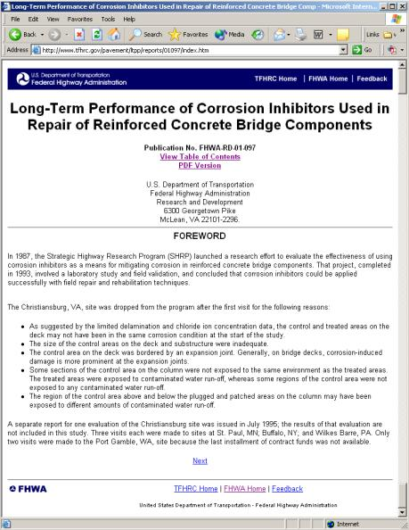
Figure 9. Screen shot. Research report Web page.

Copyright Owner: After signing the form on page 1, please fax this form to the following fax number: 202-493-xxxx

