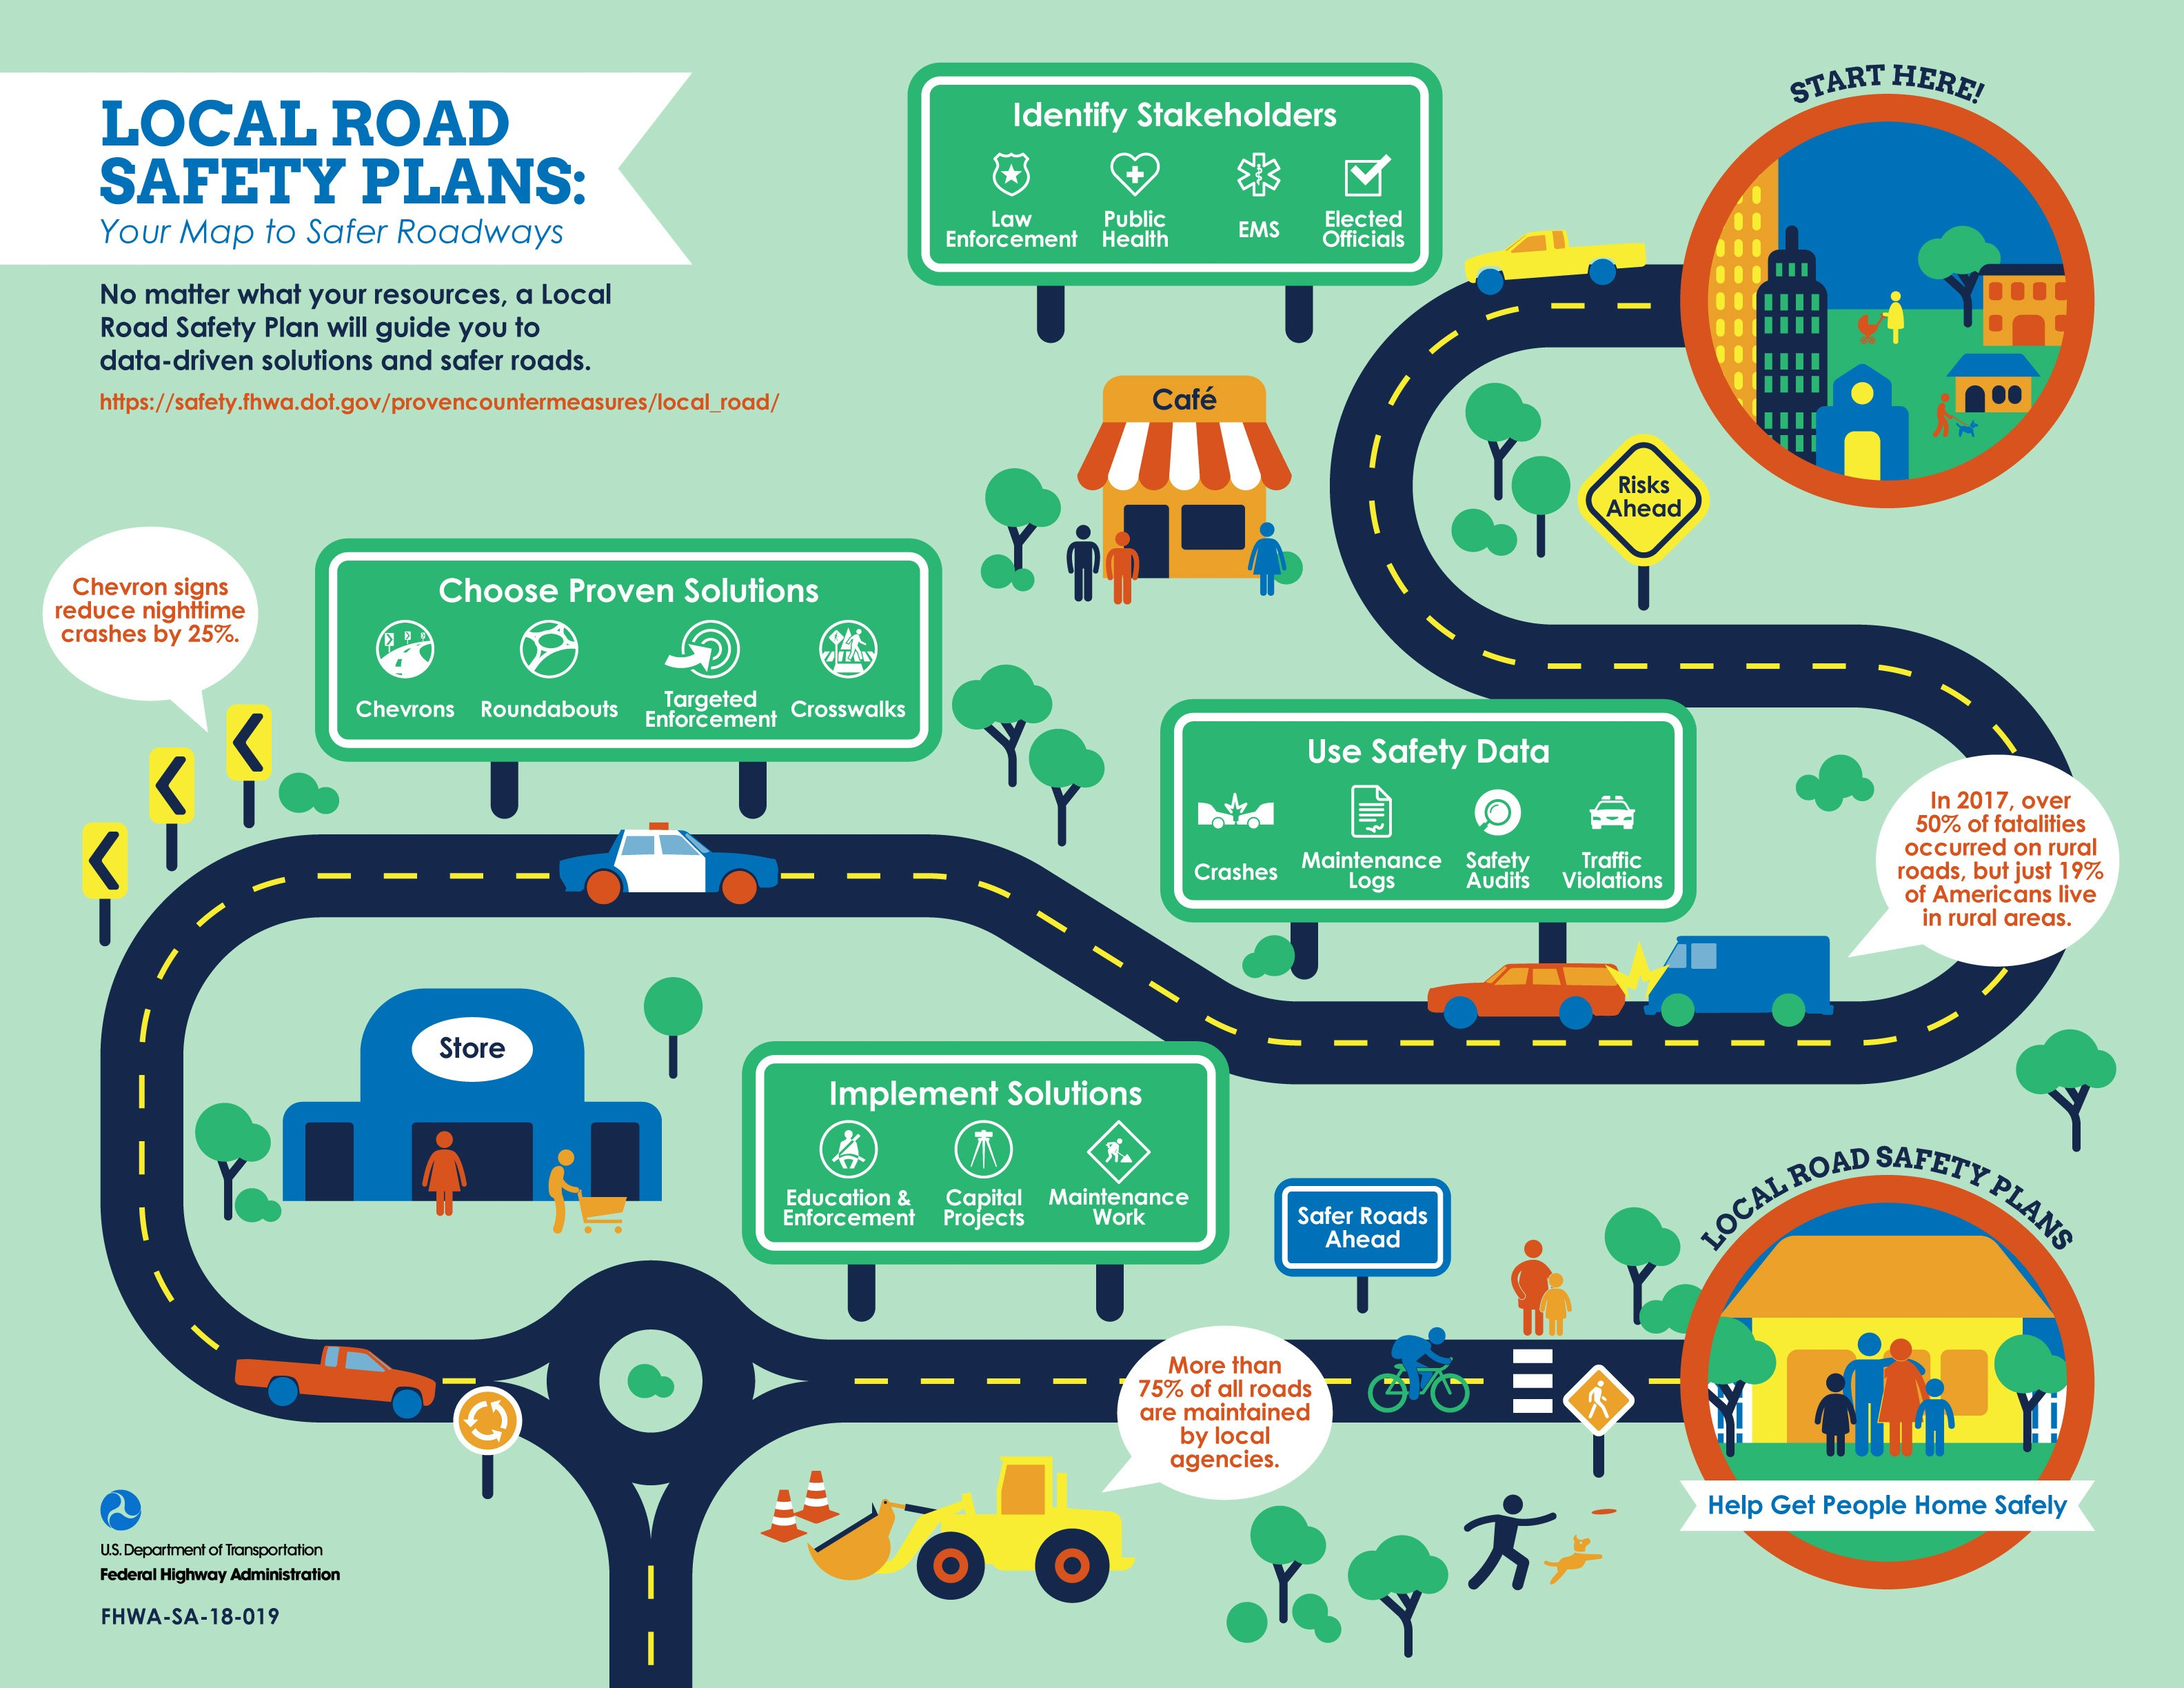

**TITLE OF PLAN**

**AGENCY**

# DATE

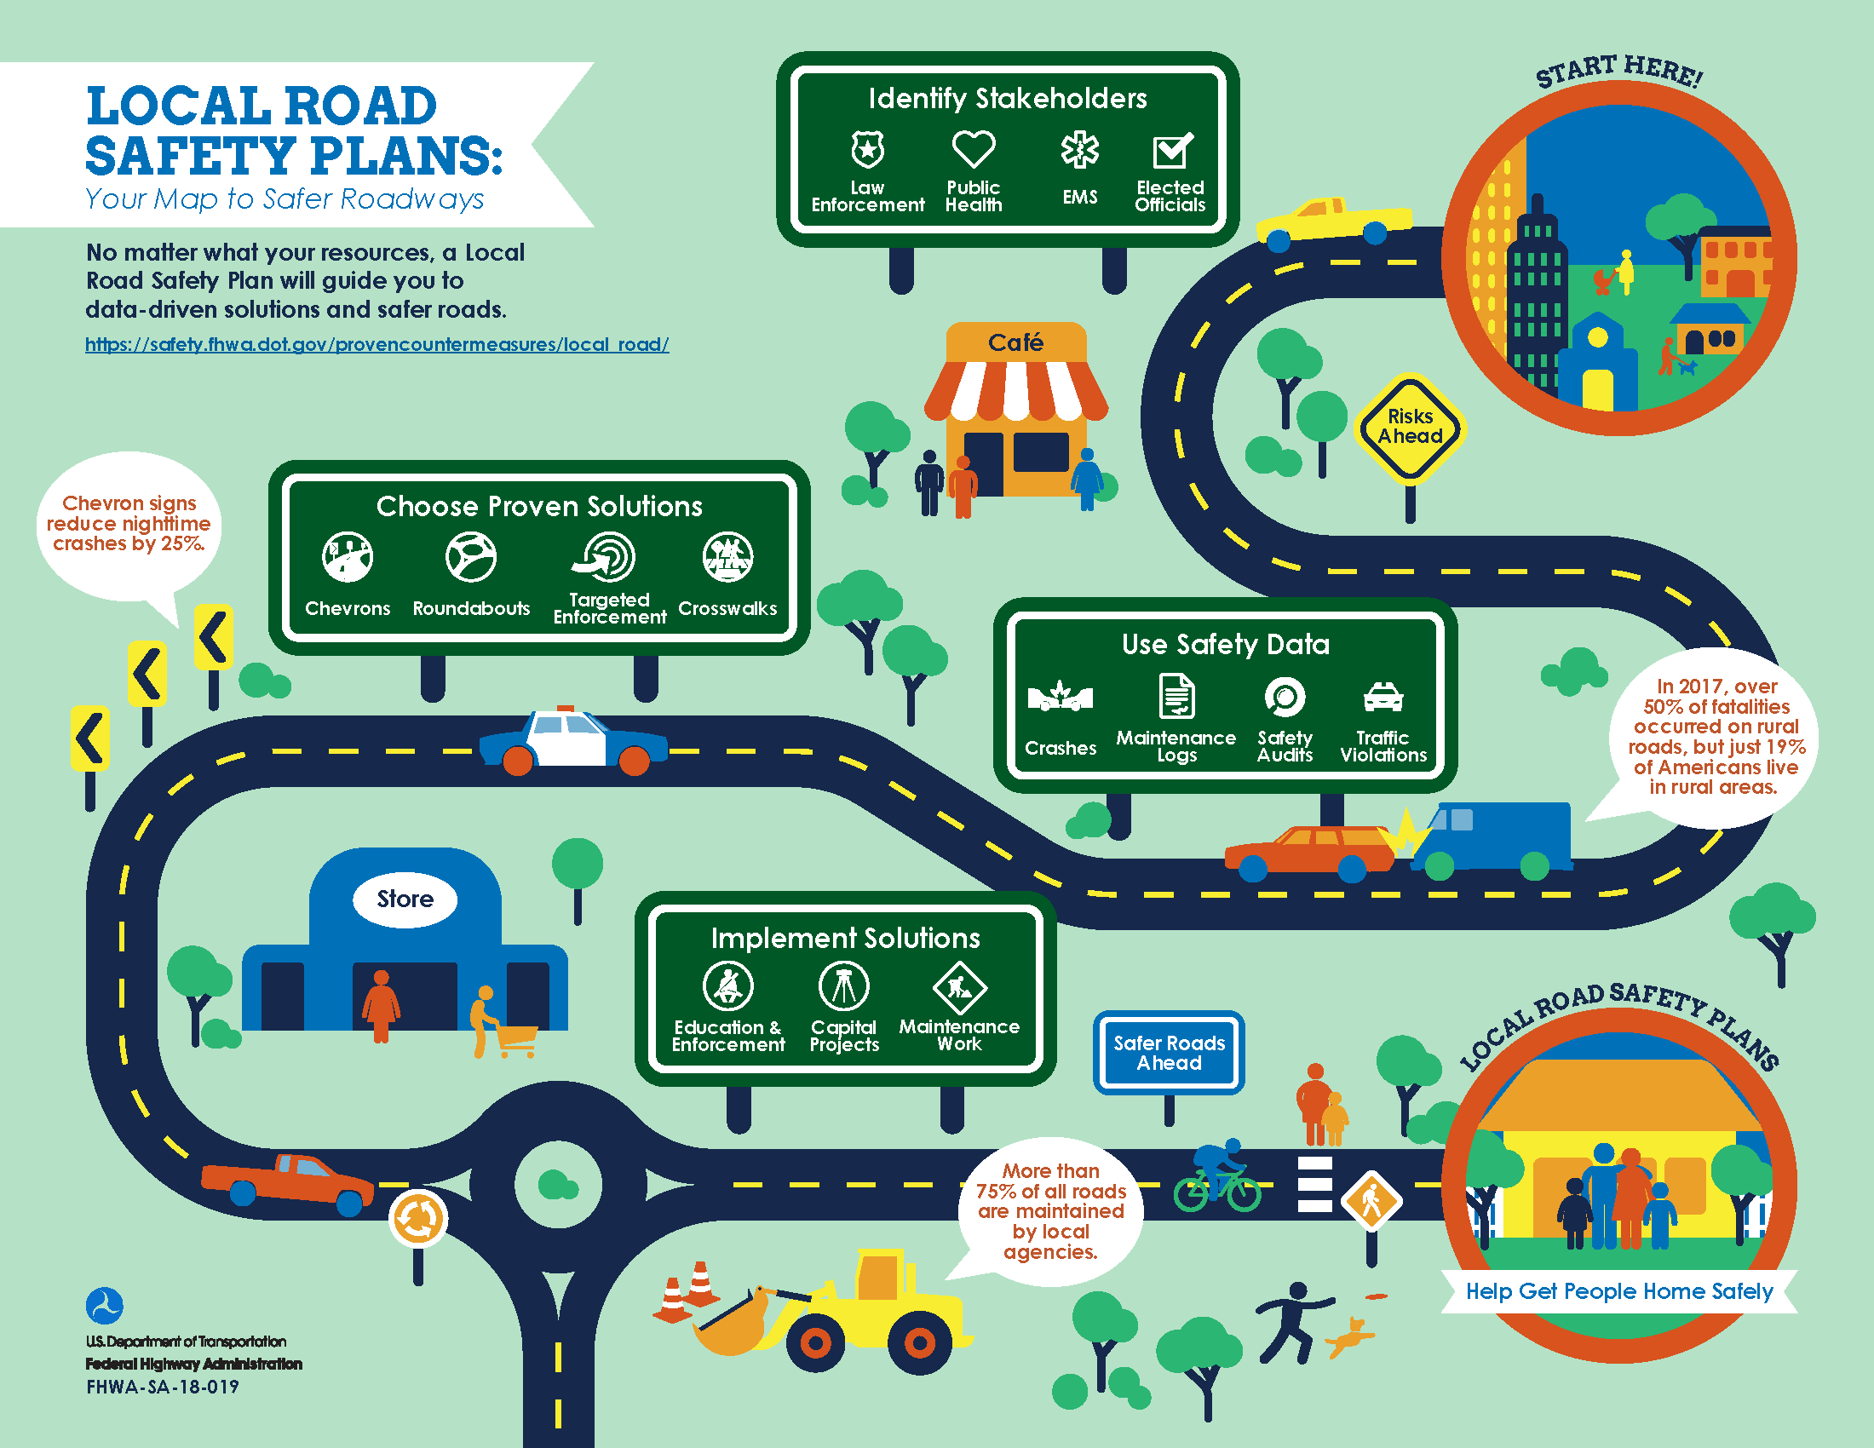*(OPTIONAL) Agency motto, slogan and/or safety message*

**Local Road Safety Plan Template**

*Feel free to use this Word document to create your safety plan planning document. Delete any instructions and examples, and then start writing!*

# INTRODUCTION

Briefly describe your Local Agency’s commitment to transportation safety through this planning process and the drafting of this document. An introduction can be one or more paragraphs, and can be as general or specific as you’d like. It serves two purposes: it gives readers an idea of what the rest of the plan will say; and it provides a reason to keep reading.

For example, you should include a description of the document; define the central concept—transportation safety; and perhaps provide some statistics that you’d like to change enough to take on this planning process.

For example, you might say, “The County is committed to improving transportation safety to reduce the risk of death and serious injury that result from incidents on our transportation systems. This plan tells the story of transportation

safety needs and strategies for our County. Implementation of the plan will improve transportation safety for the county, its people, and its visitors. As part of an ongoing effort to make safety improvements, the Local Road Safety Plan was developed with input from several safety partners. In the past 5 years, *(state some statistic that you want to improve).*

The County is targeting *(cite a goal that will improve this statistic)* over the next 5 years.”

# VISION, MISSION, & GOALS

Generate interest in the planning process by drafting vision, mission, and goals for your plan. It can be a team effort. **A worksheet to help you develop your vision, mission, and goals is available on the LRSP DIY site under Step 1: Identify Stakeholders.**

A vision statement is an idealized future description of your success. It should inspire, energize, focus, and help you and your partners picture success as you develop the plan. The best vision statements describe the desired long term, big picture outcome. E.g. *To help all users of Boone County’s transportation system to reach their destination safely (Boone County, IN Highway Department).*

A mission statement describes what an agency is going to do to achieve its vision. It states their objectives and approach. It should energize and focus you and your partners on something that everyone can work towards to achieve. E.g. *Eliminate fatal and serious injuries resulting from traffic crashes, making decisions based on their ability to reach zero deaths on Boone County’s transportation System (Boone County, IN Highway Department)*

Creating plan goals to supplement the vision and mission can help refine the team’s focus and work towards outputs and outcomes that are measurable. E.g. *Reduce the number of severe roadway departure crashes 50% by 2025.*

If you are having trouble coming up with your vision, mission, and goals, draft something now and revisit **after** you’ve gotten further along with your plan development.

# SAFETY PARTNERS

Select and identify partners that will be able to provide advice in acquiring and analyzing data, selecting emphasis areas, developing safety strategies, and implementing the final plan. For example, County Sherriff’s Department, local school, County Public Health Department, community groups, local medical professionals, etc. **A list of potential stakeholders and a State Safety Contacts database is available on the LRSP DIY site under Tools and Resources on Step 1: Identify Stakeholders.**

## List of partners here.

* Partner 1
* Partner 2
* Partner 3
* Partner 4

# PROCESS

Describe the process you used to develop the plan. This would include identification of team members, public outreach efforts, partner involvement, the timeline, etc.

# EXISTING EFFORTS

Describe your efforts, activities, programs, and policies that were already in place or in development to address transportation safety and perhaps led to this planning effort. Identify those that are being evaluated, and those that are beneficial and will continue to be implemented for the foreseeable future.

# DATA ANALYSIS and SUMMARY

Use the best available safety data. The best available data may be anything from police crash reports or database to your maintenance logs, to traffic violations, to a public involvement process depending on what is available for your local agency. If no crash data is available to you directly or from your state DOT, fatal crash data can be obtained from the National Highway Traffic Safety Administration’s Fatal Analysis Reporting System at <https://cdan.dot.gov/query>. Some local road safety plans will include Data Improvement as an emphasis area.

Note any trends shown by the available safety data and additional questions prompted by the data. Data Analysis involves looking for patterns in crash type, driver factors, roadway features, vehicle factors, or environmental condition.

Because fatal crashes in rural areas or local roads typically happen infrequently across a broad roadway network, try to use a systemic approach to safety, by identifying the characteristics present in severe crashes, and identifying where else on your roadway network has similar characteristics. Characteristics can include roadway features such as lane width, shoulder width, curvature, speed limit and traffic volume. It not necessary that these characteristics be measured values (e.g. lane width = 11 ft). Just documenting if a roadway has narrow, typical, and wide lanes or that the traffic volume is high, medium, or low will suffice. Information on performing a systemic analysis is available on the LRSP Do-It-Yourself website under Step 2: Use Safety Data.

# MAP of SEVERE CRASH LOCATIONS

Insert any meaningful tables, charts, maps, and tree diagrams here. Duplicate, or delete, this page if needed.

# CRASH DATA SUMMARY

Insert any meaningful tables, charts, maps, and tree diagrams here. Duplicate, or delete, this page if needed. **A Crash Data Summary Template to assist in summarizing crash data is available on the LRSP DIY Site under “Systemic Tools” on Step 2: Use Safety Data.**

# CRASH TREE DIAGRAMS

Insert any meaningful tables, charts, maps, and tree diagrams here. Duplicate, or delete, this page if needed. **A tool to assist in developing crash tree diagrams is available on the LRSP DIY Site under “Systemic Tools” on Step 2: Use Safety Data.**

# EMPHASIS AREAS

Many plans will include multiple emphasis areas. Emphasis areas may include three parts: a description, a goal, and strategies. Emphasis areas should describe the issue where there is opportunity to improve. Emphasis area descriptions should also explain what information led to the identification of the issue. Strategies should describe the activities that will have an impact on the issue. Consult your state’s Strategic Highway Safety Plan (SHSP) to learn about the emphasis area for the entire state. You can access your state’s SHSP at <https://safety.fhwa.dot.gov/shsp/other_resources.cfm>. Your agency’s emphasis areas could match those in the SHSP or could be different or more detailed if your severe crash issues are unique from the state as a whole.

Examples of emphasis area that might fit your situation are lane departure crashes, crashes on curves, impaired driving crashes, pedestrian safety, intersection crashes, younger drivers, data management, or night time crashes.

## Description of Emphasis Area 1: (What is the problem? Why is this emphasis area strategic?)

* Describe the emphasis area so that an outside reader could understand why emphasis is being placed on this category of incidents.
* Provide a detailed description of exactly what types of incidents the emphasis area covers.
* Provide any additional data that is specific to this subset of crashes.

## Goal for Emphasis Area 1:

* Goals provide a short-term measure that can be accomplished.
* Goals enable you to measure success and determine the appropriate time to revise the plan.

## Strategies for Emphasis Area 1:

* How will the emphasis area be addressed?
* Strategies should be implementable and should address the emphasis area.
* Who will lead implementation?

Keep this at a high level, individual action plans can be developed for each strategy later. The action plans for each strategy can detail each step that needs to be accomplished to complete the task. Assign a champion to take the lead on implementation of each high-level strategy. You may also want to consider developing a funding plan to help you implement your Local Road Safety Plan. This could include seeking Federal Highway Safety Improvement Program funds through your State DOT or using/redistributing your current funding for projects and maintenance. It’s important that your Local Road Safety Plan is not based on funding but on strategically addressing your transportation safety.

## Develop your Emphasis Areas Here.

***Emphasis area title:***

***Description:***

***Goal:***

## Strategies:

***(Strategy Champion: )***

***(Strategy Champion: ) Potential Funding Sources:***

**EVALUATION & IMPLEMENTATION**

***Describe the process that will be used to evaluate the success of the plan, ensure implementation, and determine when an update is needed.***

* How often will the goals be evaluated to measure success?
* When should revision of the plan be considered? (Living Document, every 2 years, etc.)
* Will a committee be formed to meet periodically to oversee implementation?
* Will the County hold any departments accountable for progress on the plan goals?
* Is further involvement needed from safety partners from entities outside the County?