

Proven Safety Countermeasures
Funding Scenario Briefing Templates
FHWA-SA-25-008

Overview
This document is intended to be used by State, local, Tribal, and other transportation agencies to evaluate the potential benefits of implementing the Federal Highway Administration’s (FHWA) Proven Safety Countermeasures (PSCs) within their jurisdiction. This document can be completed by an agency following completion of the accompanying PSC Investment Tool. Data from that spreadsheet can be used to fill in the highlighted portions throughout these templates, which includes a summary table of all FHWA PSCs followed by one-page summaries for each individual PSC. The spreadsheet provides the ability to prioritize investments based on Benefit-Cost Ratio (BCR) or Countermeasure Score (CM Score) based on expected changes in fatal (K) and suspected serious injury (A) crashes.

Instructions
Data for the summary table should be extracted from the “BCR Template” or “CM Score Template” tabs of the accompanying PSC spreadsheet. For both tabs, users should copy and paste the results from the “Sites Treated” column of the spreadsheet into the “Sites Treated” column of the Summary Table. Data for the “Serious Injuries Prevented” column of the Summary Table can be found in either the “Serious Injuries Prevented” column of the “BCR Template” tab or the “Serious Injuries Prevented” column of the “CM Score Template” tab. To fill out the “Lives Saved” tab of the Summary table, users should copy and paste the data from either the “Lives Saved” column of the “BCR Template” tab or the “Lives Saved” column of the “CM Score Template” tab.
For individual PSC pages in this template, users should fill in the highlighted portions with the applicable data from the PSC Investment Tool. For example, each PSC page begins with “X units - $X million over X years”. In this case, “X units” corresponds with “Sites Treated” in the spreadsheet, “$X million” corresponds with “Investment”, and “X years” corresponds with “Service Life”. To complete the “Potential $X return for every $1 spent” portion of the PSC pages, users should locate the “Estimated BCR from KA Crashes” column of the “CM Score Template” tab.

PSC Summary Table
Proven Safety Countermeasure | Investment | Lives Saved | Serious Injuries Prevented
Appropriate Speed Limits for All Road Users - Adjusting Speed Limits at Corridor Level
Speed Safety Cameras
Variable Speed Limits
Bicycle Lanes
Crosswalk Visibility Enhancements
Leading Pedestrian Interval
Medians and Pedestrian Refuge Islands in Urban and Suburban Areas
Pedestrian Hybrid Beacons
Rectangular Rapid Flashing Beacons (RRFB)
Walkways
Enhanced Delineation on Horizontal Curves
Longitudinal Rumble Strips and Stripes on Two-Lane Roads - Centerline Rumble Strips
Longitudinal Rumble Strips and Stripes on Two-Lane Roads - Edgeline or Shoulder Rumble Strips
Median Barrier - Cable
Median Barrier - Concrete
Median Barrier - Metal Guardrail
Roadside Design Improvements at Curves - Add or Widen Shoulder
Roadside Design Improvements at Curves - Flatten Side slope
Roadside Design Improvements at Curves - Roadside Barrier
Roadside Design Improvements at Curves - Treat Fixed Objects and Widen Clear Zone
Safety EdgeSM
Wider Edge Lines
Backplates with Retroreflective Borders
Corridor Access Management
Dedicated Left-Turn Lanes at Intersections
Dedicated Right-Turn Lanes at Intersections
Reduced Left-Turn Conflict Intersections
Roundabouts
Systemic Application of Multiple Low-Cost Countermeasures at Stop-Controlled Intersections
Yellow Change Intervals
Lighting - Intersection
Lighting - Segments
Local Road Safety Plans - Implement Recommended Actions and Projects
Pavement Friction Management – High Friction Surface Treatment (HFST)
Road Safety Audits - Implement Improvements
Total

Table of Contents
Leading Pedestrian Intervals 1
Medians and Pedestrian Refuge Islands 2
Pavement Friction Management – 3
High Friction Surface Treatment (HFST) 3
Reduced Left-Turn Conflict Intersections – 4
Restricted Crossing U-Turn (RCUT) 4
Reduced Left-Turn Conflict Intersections – 5
Median U-Turn (MUT) 5
Roundabouts 6
SafetyEdgeSM 7
Roadside Design Improvements at Curves: 8
Flatten Sideslope 8
Roadside Design Improvements at Curves: 9
Widen Clear Zone 9
Roadside Design Improvements at Curves: 10
Add or Widen Shoulder 10
Roadside Design Improvements at Curves: 11
Roadside Barrier 11
Longitudinal Rumble Strips and Stripes on 12
Two-Lane Roads: Centerline 12
Longitudinal Rumble Strips and Stripes on Two-Lane 13
Roads: Edgeline or Shoulder 13
Rectangular Rapid Flashing Beacons (RRFBs) 14
Crosswalk Visibility Enhancements 15
Median Barrier: Concrete 16
Median Barrier: Metal-beam guardrail 17
Median Barrier: Cable 18
Wider Edge Lines 19
Bicycle Lanes 20
Dedicated Left-Turn Lanes at Intersections 21
Dedicated Right-Turn Lanes at Intersections 22
Systemic Application of Multiple Low-Cost 23
Countermeasures at Stop-Controlled Intersections 23
Backplates with Retroreflective Borders 24
Corridor Access Management 25
Enhanced Delineation for Horizontal Curves 26
Variable Speed Limits 27
Appropriate Speed Limits 28
Lighting: Intersections 29
Lighting: Segments 30
Speed Safety Cameras (SSCs) 31
Walkways 32
Yellow Change Intervals 33
Pedestrian Hybrid Beacons (PHBs) 34
Local Road Safety Plans (LRSP) 35
Road Safety Audit (RSA) 36

Leading Pedestrian Intervals
A leading pedestrian interval (LPI) gives pedestrians the opportunity to enter the crosswalk at an intersection 3-7 seconds before vehicles are given a green indication. Pedestrians can better establish their presence in the crosswalk before vehicles have priority to turn right or left.  LPIs provide the following benefits:  • Increased visibility of crossing pedestrians.  • Reduced conflicts between pedestrians and vehicles.  • Increased likelihood of motorists yielding to pedestrians.  • Enhanced safety for pedestrians who may be slower to start into the intersection.  Enhancing pedestrian safety with LPIs addresses the Safe System principle that humans are vulnerable. |  | 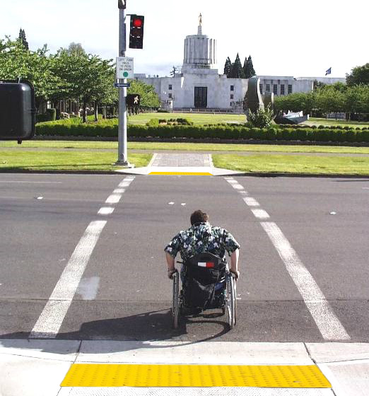  Figure 1. An LPI allows a pedestrian to establish a presence in the crosswalk before vehicles are given a green indication. Source: FHWA
Safe System Roadway Design Hierarchy Alignment:
Tier 1 - Remove Severe Conflicts | No
Tier 2 - Reduce Vehicle Speeds | No
Tier 3 - Manage Conflicts in Time | Yes
Tier 4 - Increase Attentiveness and Awareness | No

Potential Benefits of LPIs:
Number of Sites Treated  (excel tab BCR Template, Column J or excel tab CM Score Template, Column M) |  |  | # sites
Service Life of PSC  (excel tab BCR Template, Column G or excel tab CM Score Template, Column I) |  |  | # years
Number of Pedestrian Fatalities in Past 5 Years  (Input local data) |  |  | #
Number of Pedestrian Serious Injuries in Past 5 Years  (Input local data) |  |  | #
Potential Serious Injuries Prevented over Service Life  (excel tab BCR Template, Column N or excel tab CM Score Template, Column Q) |  |  | #
Potential Lives Saved over Service Life  (excel tab BCR Template, Column M or excel tab CM Score Template, Column P) |  |  | #
Estimated Cumulative Benefit  (excel tab BCR Template, Column K or excel tab CM Score Template, Column R) |  |  | $#
(BCR/CM tab, column J/M) sites – $(column K/R) over (column G/I) years
Potential $# return per $1 spent (BCR Template tab, Column C or CM Score Template tab, Column S)

Medians and Pedestrian Refuge Islands
A median is the area between opposing lanes of traffic, excluding turn lanes. Medians can be defined by pavement markings, raised medians, or islands to separate motorized and non-motorized road users.  A pedestrian refuge island (or crossing area) is a median with a refuge area that is intended to help protect pedestrians who are crossing a road.  Installing a median or pedestrian refuge island can help improve safety by removing severe conflicts between road users and allowing pedestrians to cross one direction of traffic at a time.  Some example locations that may benefit from medians or pedestrian refuge islands are mid-block crossings, approaches to multilane intersections, and areas near transit stops or other pedestrian-focused sites. |  | 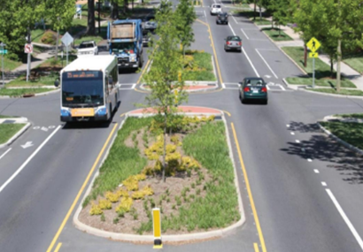  Figure 2. Example of a road with a median and pedestrian refuge islands. Source: City of Charlotte, NC
Safe System Roadway Design Hierarchy Alignment:
Tier 1 - Remove Severe Conflicts | Yes
Tier 2 - Reduce Vehicle Speeds | Yes
Tier 3 - Manage Conflicts in Time | No
Tier 4 - Increase Attentiveness and Awareness | No

Potential Benefits of Medians and Pedestrian Refuge Islands:
Number of Sites Treated  (excel tab BCR Template, Column J or excel tab CM Score Template, Column M) |  |  | # sites
Service Life of PSC  (excel tab BCR Template, Column G or excel tab CM Score Template, Column I) |  |  | # years
Number of Pedestrian Fatalities in Past 5 Years  (Input local data) |  |  | #
Number of Pedestrian Serious Injuries in Past 5 Years  (Input local data) |  |  | #
Potential Serious Injuries Prevented over Service Life  (excel tab BCR Template, Column N or excel tab CM Score Template, Column Q) |  |  | #
Potential Lives Saved over Service Life  (excel tab BCR Template, Column M or excel tab CM Score Template, Column P) |  |  | #
Estimated Cumulative Benefit  (excel tab BCR Template, Column K or excel tab CM Score Template, Column R) |  |  | $#
(BCR/CM tab, column J/M) sites – $(column K/R) over (column G/I) years
Potential $# return per $1 spent (BCR Template tab, Column C or CM Score Template tab, Column S)

Pavement Friction Management –

High Friction Surface Treatment (HFST)
Friction is a critical characteristic of a pavement that affects how vehicles interact with the roadway, including the frequency of crashes.  HFST consists of a layer of durable, anti-abrasion, and polish-resistant aggregate over a thermosetting polymer resin binder that locks the aggregate in place to restore or enhance friction and skid resistance.  HFST can be applied in locations with increased friction demand, including but not limited to:  - Horizontal curves.  - Interchange ramps.  - Intersection approaches.  - Higher-speed intersections.  - Steep downward grades. |  | 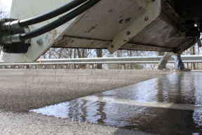  Figure 3. Automated application of HFST. Source: FHWA
Safe System Roadway Design Hierarchy Alignment:
Tier 1 - Remove Severe Conflicts | Yes
Tier 2 - Reduce Vehicle Speeds | Yes
Tier 3 - Manage Conflicts in Time | No
Tier 4 - Increase Attentiveness and Awareness | No

Potential Benefits of HFST:
Number of Sites Treated  (excel tab BCR Template, Column J or excel tab CM Score Template, Column M) |  |  | # sites
Service Life of PSC  (excel tab BCR Template, Column G or excel tab CM Score Template, Column I) |  |  | # years
Number of Roadway Departure Fatalities in Past 5 Years  (Input local data) |  |  | #
Number of Roadway Departure Serious Injuries in Past 5 Years  (Input local data) |  |  | #
Potential Serious Injuries Prevented over Service Life  (excel tab BCR Template, Column N or excel tab CM Score Template, Column Q) |  |  | #
Potential Lives Saved over Service Life  (excel tab BCR Template, Column M or excel tab CM Score Template, Column P) |  |  | #
Estimated Cumulative Benefit  (excel tab BCR Template, Column K or excel tab CM Score Template, Column R) |  |  | $#
(BCR/CM tab, column J/M) sites – $(column K/R) over (column G/I) years
Potential $# return per $1 spent (BCR Template tab, Column C or CM Score Template tab, Column S)

Reduced Left-Turn Conflict Intersections –

Restricted Crossing U-Turn (RCUT)
Left turn movements at intersections, especially high-speed intersections, introduce the potential for severe conflict crashes, (e.g., head-on or angle crashes at intersections).  The RCUT intersection modifies the direct left-turn and through movements from cross-street approaches. Instead of turning left from a cross-street approach, minor road traffic makes a right turn followed by a U-turn at a designated location—either signalized or unsignalized—to continue in the desired direction.  The RCUT is suitable for and adaptable to a wide variety of circumstances, ranging from isolated rural, high-speed locations to urban and suburban high-volume, multimodal corridors. RCUTs work well when consistently used along a corridor, but also can be used effectively at individual intersections. |  | 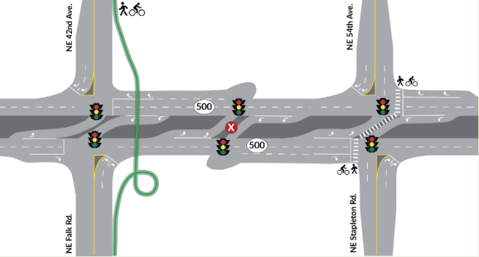  Figure 4. RCUT Intersection geometry. Source: FHWA
Safe System Roadway Design Hierarchy Alignment:
Tier 1 - Remove Severe Conflicts | Yes
Tier 2 - Reduce Vehicle Speeds | No
Tier 3 - Manage Conflicts in Time | No
Tier 4 - Increase Attentiveness and Awareness | No

Potential Benefits of RCUTs:
Number of Sites Treated  (excel tab BCR Template, Column J or excel tab CM Score Template, Column M) | # sites
Service Life of PSC  (excel tab BCR Template, Column G or excel tab CM Score Template, Column I) | # years
Number of Severe Conflict Fatalities in Past 5 Years  (Input local data) | #
Number of Severe Conflict Serious Injuries in Past 5 Years  (Input local data) | #
Potential Serious Injuries Prevented over Service Life  (excel tab BCR Template, Column N or excel tab CM Score Template, Column Q) | #
Potential Lives Saved over Service Life  (excel tab BCR Template, Column M or excel tab CM Score Template, Column P) | #
Estimated Cumulative Benefit  (excel tab BCR Template, Column K or excel tab CM Score Template, Column R) | $#
(BCR/CM tab, column J/M) sites – $(column K/R) over (column G/I) years
Potential $# return per $1 spent (BCR Template tab, Column C or CM Score Template tab, Column S)

Reduced Left-Turn Conflict Intersections –

Median U-Turn (MUT)
Left turn movements at intersections, especially high-speed intersections, introduce potential for severe conflict crashes, (e.g., head-on or angle crashes at intersections).  The MUT redirects left-turning vehicles toward downstream U-turns to reduce conflict points at the main intersection.  The MUT serves as an excellent choice for intersections with heavy through traffic and moderate left-turn volumes. When implemented at multiple intersections along a corridor, the efficient two-phase signal operation of the MUT can reduce delay, improve travel times, and create more crossing opportunities for pedestrians and bicyclists. |  | 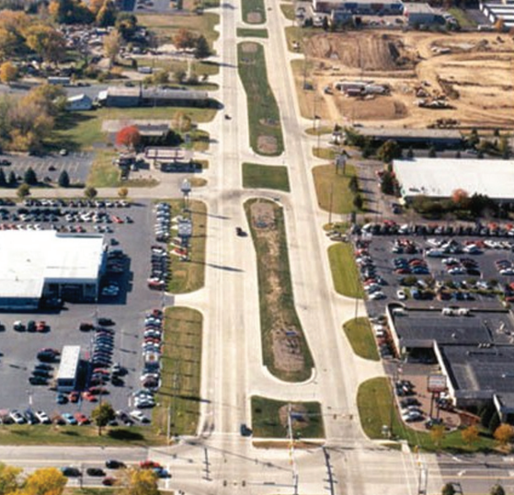  Figure 5. MUT intersection corridor. Source: FHWA
Safe System Roadway Design Hierarchy Alignment:
Tier 1 - Remove Severe Conflicts | Yes
Tier 2 - Reduce Vehicle Speeds | No
Tier 3 - Manage Conflicts in Time | No
Tier 4 - Increase Attentiveness and Awareness | No

Potential Benefits of MUTs:
Number of Sites Treated  (excel tab BCR Template, Column J or excel tab CM Score Template, Column M) |  |  | # sites
Service Life of PSC  (excel tab BCR Template, Column G or excel tab CM Score Template, Column I) |  |  | # years
Number of Severe Conflict Fatalities in Past 5 Years  (Input local data) |  |  | #
Number of Severe Conflict Serious Injuries in Past 5 Years  (Input local data) |  |  | #
Potential Serious Injuries Prevented over Service Life  (excel tab BCR Template, Column N or excel tab CM Score Template, Column Q) |  |  | #
Potential Lives Saved over Service Life  (excel tab BCR Template, Column M or excel tab CM Score Template, Column P) |  |  | #
Estimated Cumulative Benefit  (excel tab BCR Template, Column K or excel tab CM Score Template, Column R) |  |  | $#
(BCR/CM tab, column J/M) sites – $(column K/R) over (column G/I) years
Potential $# return per $1 spent (BCR Template tab, Column C or CM Score Template tab, Column S)

Roundabouts
The modern roundabout is an intersection with a circular configuration that safely and efficiently moves traffic. Roundabouts feature channelized, curved approaches that reduce vehicle speed, entry yield control that gives right-of-way to circulating traffic, and counterclockwise flow around a central island that minimizes conflict points. The net result of lower speeds and reduced conflicts at roundabouts is an environment where crashes that cause injury or fatality are substantially reduced.  Roundabouts can be implemented in both urban and rural areas under a wide range of traffic conditions. They can replace signals, two-way stop controls, and all-way stop controls. Roundabouts are an effective option for managing speed and transitioning traffic from high-speed to low-speed environments, such as freeway interchange ramp terminals, and rural intersections along high-speed roads. |  |   Figure 6. Roundabout geometry. Source: FHWA
Safe System Roadway Design Hierarchy Alignment:
Tier 1 - Remove Severe Conflicts | Yes
Tier 2 - Reduce Vehicle Speeds | Yes
Tier 3 - Manage Conflicts in Time | No
Tier 4 - Increase Attentiveness and Awareness | No

Potential Benefits of Roundabouts:
Number of Sites Treated  (excel tab BCR Template, Column J or excel tab CM Score Template, Column M) |  |  | # sites
Service Life of PSC  (excel tab BCR Template, Column G or excel tab CM Score Template, Column I) |  |  | # years
Number of Intersection Fatalities in Past 5 Years  (Input local data) |  |  | #
Number of Intersection Serious Injuries in Past 5 Years  (Input local data) |  |  | #
Potential Serious Injuries Prevented over Service Life  (excel tab BCR Template, Column N or excel tab CM Score Template, Column Q) |  |  | #
Potential Lives Saved over Service Life  (excel tab BCR Template, Column M or excel tab CM Score Template, Column P) |  |  | #
Estimated Cumulative Benefit  (excel tab BCR Template, Column K or excel tab CM Score Template, Column R) |  |  | $#
(BCR/CM tab, column J/M) sites – $(column K/R) over (column G/I) years
Potential $# return per $1 spent (BCR Template tab, Column C or CM Score Template tab, Column S)

SafetyEdgeSM
Fatalities are 2-4 times more likely to occur when a rural road crash involves a pavement edge drop-off, which can cause vehicles to lose stability if they depart the roadway and make it more difficult to return to the travel lane.  The SafetyEdgeSM shapes the edge of the pavement at approximately 30 degrees from the pavement cross slope during the paving process. This eliminates the potential for vertical drop-off at the pavement edge, has minimal effect on project cost, and can improve pavement durability by reducing edge raveling. |  | 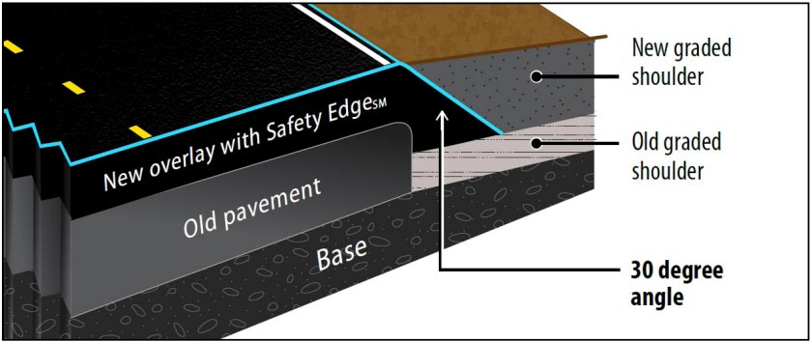  Figure 7. Cross-section view of an overlay with the SafetyEdgeSM. Source: FHWA
Safe System Roadway Design Hierarchy Alignment:
Tier 1 - Remove Severe Conflicts | Yes
Tier 2 - Reduce Vehicle Speeds | No
Tier 3 - Manage Conflicts in Time | No
Tier 4 - Increase Attentiveness and Awareness | No

Potential Benefits of SafetyEdgeSM:
Number of Sites Treated  (excel tab BCR Template, Column J or excel tab CM Score Template, Column M) |  |  | # sites
Service Life of PSC  (excel tab BCR Template, Column G or excel tab CM Score Template, Column I) |  |  | # years
Number of Roadway Departure Fatalities in Past 5 Years  (Input local data) |  |  | #
Number of Roadway Departure Serious Injuries in Past 5 Years  (Input local data) |  |  | #
Potential Serious Injuries Prevented over Service Life  (excel tab BCR Template, Column N or excel tab CM Score Template, Column Q) |  |  | #
Potential Lives Saved over Service Life  (excel tab BCR Template, Column M or excel tab CM Score Template, Column P) |  |  | #
Estimated Cumulative Benefit  (excel tab BCR Template, Column K or excel tab CM Score Template, Column R) |  |  | $#
(BCR/CM tab, column J/M) sites – $(column K/R) over (column G/I) years
Potential $# return per $1 spent (BCR Template tab, Column C or CM Score Template tab, Column S)

Roadside Design Improvements at Curves:

Flatten Sideslope
Roadside design improvements at curves are a strategy encompassing several treatments that target the high-risk roadside environment along the outside of horizontal curves. These treatments can reduce roadway lane fatalities and serious injuries by giving vehicles the opportunity to recover safely and by reducing crash severity.  Slope flattening reduces the steepness of the sideslope to increase drivers’ ability to keep the vehicle stable, regain control of the vehicle, and avoid obstacles. Slopes of 1V:4H or flatter are considered recoverable (drivers can retain control of a vehicle by slowing or stopping). Slopes between 1V:3H and 1V:4H are generally considered traversable, but non-recoverable (errant vehicle will continue to the bottom of the slope). |  | 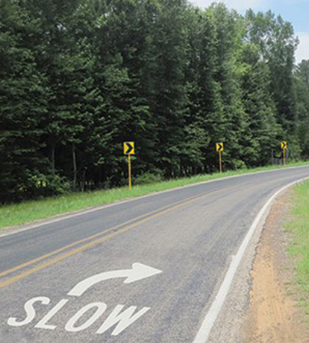  Figure 8. Example of a flattened sideslope. Source: FHWA
Safe System Roadway Design Hierarchy Alignment:
Tier 1 - Remove Severe Conflicts | Yes
Tier 2 - Reduce Vehicle Speeds | No
Tier 3 - Manage Conflicts in Time | No
Tier 4 - Increase Attentiveness and Awareness | No

Potential Benefits of Flattened Sideslopes:
Number of Sites Treated  (excel tab BCR Template, Column J or excel tab CM Score Template, Column M) |  |  | # sites
Service Life of PSC  (excel tab BCR Template, Column G or excel tab CM Score Template, Column I) |  |  | # years
Number of Roadway Departure Fatalities in Past 5 Years  (Input local data) |  |  | #
Number of Roadway Departure Serious Injuries in Past 5 Years  (Input local data) |  |  | #
Potential Serious Injuries Prevented over Service Life  (excel tab BCR Template, Column N or excel tab CM Score Template, Column Q) |  |  | #
Potential Lives Saved over Service Life  (excel tab BCR Template, Column M or excel tab CM Score Template, Column P) |  |  | #
Estimated Cumulative Benefit  (excel tab BCR Template, Column K or excel tab CM Score Template, Column R) |  |  | $#
(BCR/CM tab, column J/M) sites – $(column K/R) over (column G/I) years
Potential $# return per $1 spent (BCR Template tab, Column C or CM Score Template tab, Column S)

Roadside Design Improvements at Curves:

Widen Clear Zone
Roadside design improvements at curves are a strategy encompassing several treatments that target the high-risk roadside environment along the outside of horizontal curves. These treatments can reduce roadway departure fatalities and serious injuries by giving vehicles the opportunity to recover safely and by reducing crash severity.  A clear zone is an unobstructed, traversable roadside area that allows a driver to stop safely or regain control of a vehicle that has left the roadway. Agencies should avoid adding new fixed objects such as trees and utility cabinets or poles in the clear zone. |  | 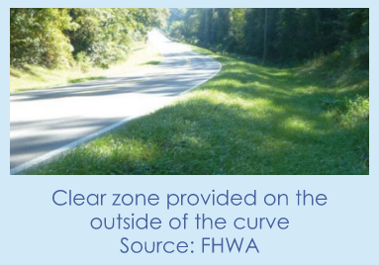  Figure 9. Clear zone provided on the outside of the curve. Source: FHWA
Safe System Roadway Design Hierarchy Alignment:
Tier 1 - Remove Severe Conflicts | Yes
Tier 2 - Reduce Vehicle Speeds | No
Tier 3 - Manage Conflicts in Time | No
Tier 4 - Increase Attentiveness and Awareness | No

Potential Benefits of Widened Clear Zones:
Number of Sites Treated  (excel tab BCR Template, Column J or excel tab CM Score Template, Column M) | # sites
Service Life of PSC  (excel tab BCR Template, Column G or excel tab CM Score Template, Column I) | # years
Number of Roadway Departure Fatalities in Past 5 Years  (Input local data) | #
Number of Roadway Departure Serious Injuries in Past 5 Years  (Input local data) | #
Potential Serious Injuries Prevented over Service Life  (excel tab BCR Template, Column N or excel tab CM Score Template, Column Q) | #
Potential Lives Saved over Service Life  (excel tab BCR Template, Column M or excel tab CM Score Template, Column P) | #
Estimated Cumulative Benefit  (excel tab BCR Template, Column K or excel tab CM Score Template, Column R) | $#
(BCR/CM tab, column J/M) sites – $(column K/R) over (column G/I) years
Potential $# return per $1 spent (BCR Template tab, Column C or CM Score Template tab, Column S)

Roadside Design Improvements at Curves:

Add or Widen Shoulder
Roadside design improvements at curves are a strategy encompassing several treatments that target the high-risk roadside environment along the outside of horizontal curves. These treatments can reduce roadway departure fatalities and serious injuries by giving vehicles the opportunity to recover safely and by reducing crash severity.  Adding or widening shoulders gives drivers more recovery area to regain control in the event of a roadway departure. |  | 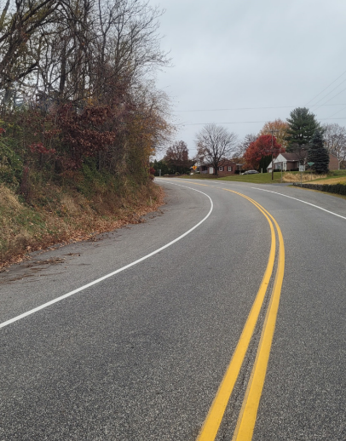  Figure 10. Example of a widened shoulder. Source: FHWA
Safe System Roadway Design Hierarchy Alignment:
Tier 1 - Remove Severe Conflicts | Yes
Tier 2 - Reduce Vehicle Speeds | No
Tier 3 - Manage Conflicts in Time | No
Tier 4 - Increase Attentiveness and Awareness | No

Potential Benefits of Additional or Widened Shoulders:
Number of Sites Treated  (excel tab BCR Template, Column J or excel tab CM Score Template, Column M) | # sites
Service Life of PSC  (excel tab BCR Template, Column G or excel tab CM Score Template, Column I) | # years
Number of Roadway Departure Fatalities in Past 5 Years  (Input local data) | #
Number of Roadway Departure Serious Injuries in Past 5 Years  (Input local data) | #
Potential Serious Injuries Prevented over Service Life  (excel tab BCR Template, Column N or excel tab CM Score Template, Column Q) | #
Potential Lives Saved over Service Life  (excel tab BCR Template, Column M or excel tab CM Score Template, Column P) | #
Estimated Cumulative Benefit  (excel tab BCR Template, Column K or excel tab CM Score Template, Column R) | $#
(BCR/CM tab, column J/M) sites – $(column K/R) over (column G/I) years
Potential $# return per $1 spent (BCR Template tab, Column C or CM Score Template tab, Column S)

Roadside Design Improvements at Curves:

Roadside Barrier
Since not all roadside hazards can be removed, relocated, or redesigned at curves, installing roadside barriers to shield unmovable objects or steep embankments may be an appropriate treatment.  Cable barriers are flexible barriers made from steel cables mounted on weak steel posts. Flexible barriers are more forgiving and have the most deflection.  Metal-beam guardrails are semi-rigid barriers where a W-beam or box-beam is mounted on steel or timber posts. These deflect less than cable barriers, so they can be located closer to objects where space is limited.  Concrete barriers are rigid barriers that have little to no deflection. |  | 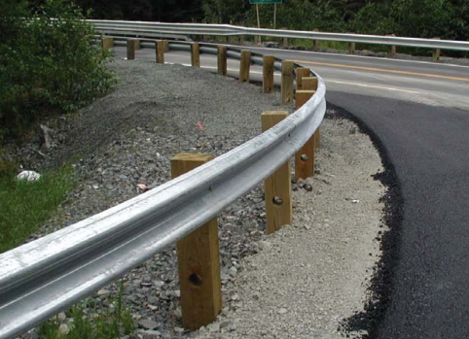  Figure 21. Example of a metal-beam guardrail roadside barrier at a horizontal curve. Source: FHWA
Safe System Roadway Design Hierarchy Alignment:
Tier 1 - Remove Severe Conflicts | Yes
Tier 2 - Reduce Vehicle Speeds | No
Tier 3 - Manage Conflicts in Time | No
Tier 4 - Increase Attentiveness and Awareness | No

Potential Benefits of Roadside Barriers:
Number of Sites Treated  (excel tab BCR Template, Column J or excel tab CM Score Template, Column M) | # sites
Service Life of PSC  (excel tab BCR Template, Column G or excel tab CM Score Template, Column I) | # years
Number of Roadway Departure Fatalities in Past 5 Years  (Input local data) | #
Number of Roadway Departure Serious Injuries in Past 5 Years  (Input local data) | #
Potential Serious Injuries Prevented over Service Life  (excel tab BCR Template, Column N or excel tab CM Score Template, Column Q) | #
Potential Lives Saved over Service Life  (excel tab BCR Template, Column M or excel tab CM Score Template, Column P) | #
Estimated Cumulative Benefit  (excel tab BCR Template, Column K or excel tab CM Score Template, Column R) | $#
(BCR/CM tab, column J/M) sites – $(column K/R) over (column G/I) years
Potential $# return per $1 spent (BCR Template tab, Column C or CM Score Template tab, Column S)

Longitudinal Rumble Strips and Stripes on

Two-Lane Roads: Centerline
Center line rumble strips and stripes (where the pavement marking is placed over the rumble strip) are milled or rolled-in corrugations in the pavement to alert inattentive drivers that they are leaving their lane.  Center line rumble strips and stripes can be used in both passing and no passing zones wherever an agency has identified risk factors (such as lane width, shoulder width, median type, horizontal curvature, or crash history), that indicate a higher probability of head-on crashes. |  | 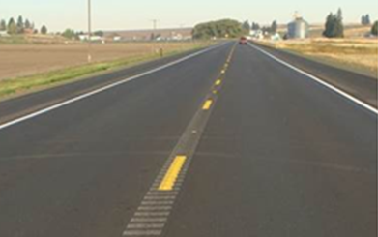  Figure 33. Rumble stripes are installed along the centerline of this roadway. Source: FHWA
Safe System Roadway Design Hierarchy Alignment:
Tier 1 - Remove Severe Conflicts | No
Tier 2 - Reduce Vehicle Speeds | No
Tier 3 - Manage Conflicts in Time | No
Tier 4 - Increase Attentiveness and Awareness | Yes

Potential Benefits of Centerline Rumble Strips and Stripes:
Number of Sites Treated  (excel tab BCR Template, Column J or excel tab CM Score Template, Column M) | # sites
Service Life of PSC  (excel tab BCR Template, Column G or excel tab CM Score Template, Column I) | # years
Number of Roadway Departure Fatalities in Past 5 Years  (Input local data) | #
Number of Roadway Departure Serious Injuries in Past 5 Years  (Input local data) | #
Potential Serious Injuries Prevented over Service Life  (excel tab BCR Template, Column N or excel tab CM Score Template, Column Q) | #
Potential Lives Saved over Service Life  (excel tab BCR Template, Column M or excel tab CM Score Template, Column P) | #
Estimated Cumulative Benefit  (excel tab BCR Template, Column K or excel tab CM Score Template, Column R) | $#
(BCR/CM tab, column J/M) sites – $(column K/R) over (column G/I) years
Potential $# return per $1 spent (BCR Template tab, Column C or CM Score Template tab, Column S)

Longitudinal Rumble Strips and Stripes on Two-Lane

Roads: Edgeline or Shoulder
Shoulder rumble strips and stripes (where the pavement marking is placed over the rumble strip) are milled or rolled-in corrugations in the pavement to alert inattentive drivers that they are leaving their lane.  Shoulder or edge line rumble strips and stripes can be used wherever risk factors indicate a higher probability of run-off-road crashes. |  | 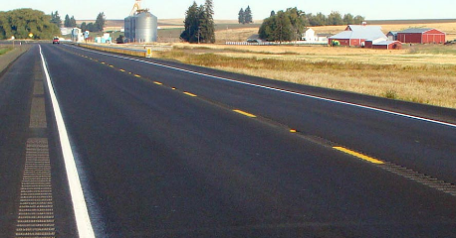  Figure 44. Rumble strips are installed on the shoulder of this roadway. Source: FHWA
Safe System Roadway Design Hierarchy Alignment:
Tier 1 - Remove Severe Conflicts | No
Tier 2 - Reduce Vehicle Speeds | No
Tier 3 - Manage Conflicts in Time | No
Tier 4 - Increase Attentiveness and Awareness | Yes

Potential Benefits of Edgeline Rumble Strips or Stripes:
Number of Sites Treated  (excel tab BCR Template, Column J or excel tab CM Score Template, Column M) | # sites
Service Life of PSC  (excel tab BCR Template, Column G or excel tab CM Score Template, Column I) | # years
Number of Roadway Departure Fatalities in Past 5 Years  (Input local data) | #
Number of Roadway Departure Serious Injuries in Past 5 Years  (Input local data) | #
Potential Serious Injuries Prevented over Service Life  (excel tab BCR Template, Column N or excel tab CM Score Template, Column Q) | #
Potential Lives Saved over Service Life  (excel tab BCR Template, Column M or excel tab CM Score Template, Column P) | #
Estimated Cumulative Benefit  (excel tab BCR Template, Column K or excel tab CM Score Template, Column R) | $#
(BCR/CM tab, column J/M) sites – $(column K/R) over (column G/I) years
Potential $# return per $1 spent (BCR Template tab, Column C or CM Score Template tab, Column S)

Rectangular Rapid Flashing Beacons (RRFBs)
To enhance pedestrian conspicuity and increase driver awareness at uncontrolled, marked crosswalks, transportation agencies can install a pedestrian actuated Rectangular Rapid Flashing Beacon (RRFB) to accompany a pedestrian warning sign. RRFBs consist of two, rectangular- shaped yellow indications, each with a light-emitting diode (LED)-array-based light source. RRFBs flash with an alternating high frequency when activated to enhance conspicuity of pedestrians at the crossing to drivers.  The RRFB is applicable to many types of pedestrian crossings but is particularly effective at multilane crossings with speed limits less than 40 miles per hour. Research suggests RRFBs can result in motorist yielding rates as high at 98 percent at marked crosswalks, but varies depending on the location, posted speed limit, pedestrian crossing distance, one- versus two-way road, and the number of travel lanes. RRFBs can also accompany school or trail crossing warning signs. |  | 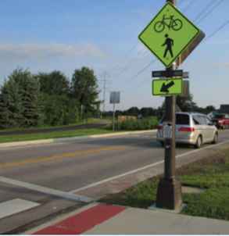  Figure 55. RRFBs used at a trail crossing. Source: LJB
Safe System Roadway Design Hierarchy Alignment:
Tier 1 - Remove Severe Conflicts | No
Tier 2 - Reduce Vehicle Speeds | No
Tier 3 - Manage Conflicts in Time | No
Tier 4 - Increase Attentiveness and Awareness | Yes

Potential Benefits of RRFBs:
Number of Sites Treated  (excel tab BCR Template, Column J or excel tab CM Score Template, Column M) |  |  | # sites
Service Life of PSC  (excel tab BCR Template, Column G or excel tab CM Score Template, Column I) |  |  | # years
Number of Pedestrian Fatalities in Past 5 Years  (Input local data) |  |  | #
Number of Pedestrian Serious Injuries in Past 5 Years  (Input local data) |  |  | #
Potential Serious Injuries Prevented over Service Life  (excel tab BCR Template, Column N or excel tab CM Score Template, Column Q) |  |  | #
Potential Lives Saved over Service Life  (excel tab BCR Template, Column M or excel tab CM Score Template, Column P) |  |  | #
Estimated Cumulative Benefit  (excel tab BCR Template, Column K or excel tab CM Score Template, Column R) |  |  | $#
(BCR/CM tab, column J/M) sites – $(column K/R) over (column G/I) years
Potential $# return per $1 spent (BCR Template tab, Column C or CM Score Template tab, Column S)

Crosswalk Visibility Enhancements
Three main crosswalk visibility enhancements can help make crosswalks and the individuals traversing them more visible to drivers. These include high-visibility crosswalks, lighting, and signing and pavement markings.  High-visibility crosswalks use patterns (i.e., bar pairs, continental, ladder) that are visible to both the driver and pedestrian from farther away compared to traditional transverse line crosswalks.  Crosswalk lighting can be used to illuminate with positive contrast to make it easier for a driver to see a pedestrian.  On multilane roadways, agencies can use “YIELD Here to Pedestrians” or “STOP Here for Pedestrians” signs 20-50 feet in advance of a marked crosswalk to indicate where a driver should stop or yield to pedestrians. |  | 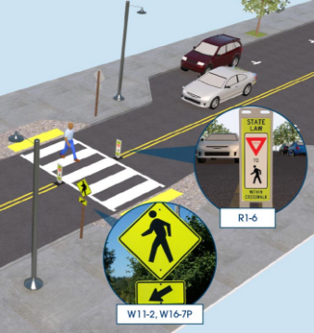  Figure 66. Example of a roadway with crosswalk visibility enhancements. Source: FHWA
Safe System Roadway Design Hierarchy Alignment:
Tier 1 - Remove Severe Conflicts | No
Tier 2 - Reduce Vehicle Speeds | No
Tier 3 - Manage Conflicts in Time | No
Tier 4 - Increase Attentiveness and Awareness | Yes

Potential Benefits of Crosswalk Visibility Enhancements:
Number of Sites Treated  (excel tab BCR Template, Column J or excel tab CM Score Template, Column M) |  |  | # sites
Service Life of PSC  (excel tab BCR Template, Column G or excel tab CM Score Template, Column I) |  |  | # years
Number of Pedestrian Fatalities in Past 5 Years  (Input local data) |  |  | #
Number of Pedestrian Serious Injuries in Past 5 Years  (Input local data) |  |  | #
Potential Serious Injuries Prevented over Service Life  (excel tab BCR Template, Column N or excel tab CM Score Template, Column Q) |  |  | #
Potential Lives Saved over Service Life  (excel tab BCR Template, Column M or excel tab CM Score Template, Column P) |  |  | #
Estimated Cumulative Benefit  (excel tab BCR Template, Column K or excel tab CM Score Template, Column R) |  |  | $#
(BCR/CM tab, column J/M) sites – $(column K/R) over (column G/I) years
Potential $# return per $1 spent (BCR Template tab, Column C or CM Score Template tab, Column S)

Median Barrier: Concrete
Median barriers are longitudinal barriers that separate opposing traffic on a divided highway and are designed to redirect vehicles striking either side of the barrier. Median barriers are part of the safe roads element of the safe system approach.  Concrete barriers are usually rigid and result in little to no deflection. They redirect rather than absorb energy from the impact. |  |   Figure 77. Example of a concrete median barrier. Source: Getty Images
Safe System Roadway Design Hierarchy Alignment:
Tier 1 - Remove Severe Conflicts | Yes
Tier 2 - Reduce Vehicle Speeds | No
Tier 3 - Manage Conflicts in Time | No
Tier 4 - Increase Attentiveness and Awareness | No

Potential Benefits of Concrete Median Barriers:
Number of Sites Treated  (excel tab BCR Template, Column J or excel tab CM Score Template, Column M) | # sites
Service Life of PSC  (excel tab BCR Template, Column G or excel tab CM Score Template, Column I) | # years
Number of Roadway Departure Fatalities in Past 5 Years  (Input local data) | #
Number of Roadway Departure Serious Injuries in Past 5 Years  (Input local data) | #
Potential Serious Injuries Prevented over Service Life  (excel tab BCR Template, Column N or excel tab CM Score Template, Column Q) | #
Potential Lives Saved over Service Life  (excel tab BCR Template, Column M or excel tab CM Score Template, Column P) | #
Estimated Cumulative Benefit  (excel tab BCR Template, Column K or excel tab CM Score Template, Column R) | $#
(BCR/CM tab, column J/M) sites – $(column K/R) over (column G/I) years
Potential $# return per $1 spent (BCR Template tab, Column C or CM Score Template tab, Column S)

Median Barrier: Metal-beam guardrail
Median barriers are longitudinal barriers that separate opposing traffic on a divided highway and are designed to redirect vehicles striking either side of the barrier. Median barriers are part of the safe roads element of the safe system approach.  Metal-beam guardrails are considered semi-rigid barriers, where the W-beam or box-beam is mounted to steel or timber posts. When impacted, they are designed to deform and deflect, absorbing some of the crash energy and redirecting the vehicle. |  | 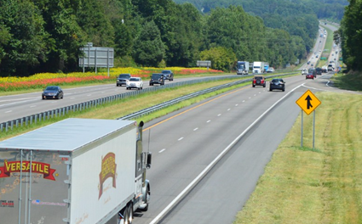  Figure 88. Example of a metal median barrier. Source: NCDOT
Safe System Roadway Design Hierarchy Alignment:
Tier 1 - Remove Severe Conflicts | Yes
Tier 2 - Reduce Vehicle Speeds | No
Tier 3 - Manage Conflicts in Time | No
Tier 4 - Increase Attentiveness and Awareness | No

Potential Benefits of Metal Median Barriers:
Number of Sites Treated  (excel tab BCR Template, Column J or excel tab CM Score Template, Column M) | # sites
Service Life of PSC  (excel tab BCR Template, Column G or excel tab CM Score Template, Column I) | # years
Number of Roadway Departure Fatalities in Past 5 Years  (Input local data) | #
Number of Roadway Departure Serious Injuries in Past 5 Years  (Input local data) | #
Potential Serious Injuries Prevented over Service Life  (excel tab BCR Template, Column N or excel tab CM Score Template, Column Q) | #
Potential Lives Saved over Service Life  (excel tab BCR Template, Column M or excel tab CM Score Template, Column P) | #
Estimated Cumulative Benefit  (excel tab BCR Template, Column K or excel tab CM Score Template, Column R) | $#
(BCR/CM tab, column J/M) sites – $(column K/R) over (column G/I) years
Potential $# return per $1 spent (BCR Template tab, Column C or CM Score Template tab, Column S)

Median Barrier: Cable
Median barriers are longitudinal barriers that separate opposing traffic on a divided highway and are designed to redirect vehicles striking either side of the barrier. Median barriers are part of the safe roads element of the safe system approach.  Cable barriers are flexible barriers, made from steel cables mounted on weak steel posts. Impacting a cable barrier results in less occupant impact force as the cable barrier absorbs energy from the crash, capturing or redirecting the vehicle. |  | 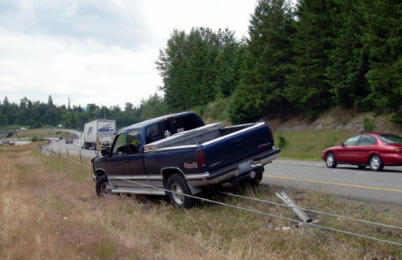  Figure 9. Median cable barrier prevents a potential head-on crash. Source: WSDOT
Safe System Roadway Design Hierarchy Alignment:
Tier 1 - Remove Severe Conflicts | Yes
Tier 2 - Reduce Vehicle Speeds | No
Tier 3 - Manage Conflicts in Time | No
Tier 4 - Increase Attentiveness and Awareness | No

Potential Benefits of Cable Median Barriers:
Number of Sites Treated  (excel tab BCR Template, Column J or excel tab CM Score Template, Column M) | # sites
Service Life of PSC  (excel tab BCR Template, Column G or excel tab CM Score Template, Column I) | # years
Number of Roadway Departure Fatalities in Past 5 Years  (Input local data) | #
Number of Roadway Departure Serious Injuries in Past 5 Years  (Input local data) | #
Potential Serious Injuries Prevented over Service Life  (excel tab BCR Template, Column N or excel tab CM Score Template, Column Q) | #
Potential Lives Saved over Service Life  (excel tab BCR Template, Column M or excel tab CM Score Template, Column P) | #
Estimated Cumulative Benefit  (excel tab BCR Template, Column K or excel tab CM Score Template, Column R) | $#
(BCR/CM tab, column J/M) sites – $(column K/R) over (column G/I) years
Potential $# return per $1 spent (BCR Template tab, Column C or CM Score Template tab, Column S)

Wider Edge Lines
Wider edge lines enhance the visibility of travel lane boundaries compared to traditional edge lines. Edge lines are considered “wider” when the marking width is increased from the minimum normal line width of 4 inches to the maximum normal line width of 6 inches (MUTCD 3A.04).  Wider edge lines increase drivers’ perception of the edge of the travel lane and can provide a safety benefit to all facility types (e.g., freeways, multilane divided and undivided highways, two-lane highways) in both urban and rural areas. |  | 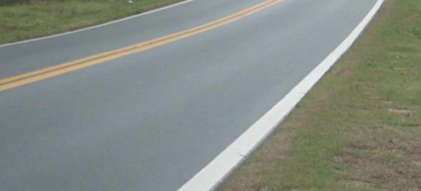  Figure 20. Example of a roadway with a wide edge line. Source: Texas Transportation Institute
Safe System Roadway Design Hierarchy Alignment:
Tier 1 - Remove Severe Conflicts | No
Tier 2 - Reduce Vehicle Speeds | No
Tier 3 - Manage Conflicts in Time | No
Tier 4 - Increase Attentiveness and Awareness | Yes

Potential Benefits of Wider Edge Lines:
Number of Sites Treated  (excel tab BCR Template, Column J or excel tab CM Score Template, Column M) | # sites
Service Life of PSC  (excel tab BCR Template, Column G or excel tab CM Score Template, Column I) | # years
Number of Roadway Departure Fatalities in Past 5 Years  (Input local data) | #
Number of Roadway Departure Serious Injuries in Past 5 Years  (Input local data) | #
Potential Serious Injuries Prevented over Service Life  (excel tab BCR Template, Column N or excel tab CM Score Template, Column Q) | #
Potential Lives Saved over Service Life  (excel tab BCR Template, Column M or excel tab CM Score Template, Column P) | #
Estimated Cumulative Benefit  (excel tab BCR Template, Column K or excel tab CM Score Template, Column R) | $#
(BCR/CM tab, column J/M) sites – $(column K/R) over (column G/I) years
Potential $# return per $1 spent (BCR Template tab, Column C or CM Score Template tab, Column S)

Bicycle Lanes
Most fatal and serious injury bicyclist crashes occur at non-intersection locations. Nearly one-third of these crashes occur when motorists are overtaking bicyclists.  Providing bicycle lanes can mitigate or prevent interactions, conflicts, and crashes between bicyclists and motor vehicles, and create a network of safer roadways for bicycling. Bicycle lanes can be included on new roadways or created on existing roads. Separated bicycle lanes, which use vertical elements—such as flexible delineator posts, curbs, or vegetation—between the bicycle lane and motorized traffic lanes provide additional safety benefits. |  | 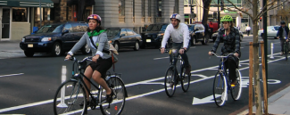  Figure 210. Bicycle lane in Washington, DC. Source: Washington Area Bicyclist Association
Safe System Roadway Design Hierarchy Alignment:
Tier 1 - Remove Severe Conflicts | Yes
Tier 2 - Reduce Vehicle Speeds | No
Tier 3 - Manage Conflicts in Time | No
Tier 4 - Increase Attentiveness and Awareness | No

Potential Benefits of Bicycle Lanes:
Number of Sites Treated  (excel tab BCR Template, Column J or excel tab CM Score Template, Column M) | # sites
Service Life of PSC  (excel tab BCR Template, Column G or excel tab CM Score Template, Column I) | # years
Number of Cyclist Fatalities in Past 5 Years  (Input local data) | #
Number of Cyclist Serious Injuries in Past 5 Years  (Input local data) | #
Potential Serious Injuries Prevented over Service Life  (excel tab BCR Template, Column N or excel tab CM Score Template, Column Q) | #
Potential Lives Saved over Service Life  (excel tab BCR Template, Column M or excel tab CM Score Template, Column P) | #
Estimated Cumulative Benefit  (excel tab BCR Template, Column K or excel tab CM Score Template, Column R) | $#
(BCR/CM tab, column J/M) sites – $(column K/R) over (column G/I) years
Potential $# return per $1 spent (BCR Template tab, Column C or CM Score Template tab, Column S)

Dedicated Left-Turn Lanes at Intersections
Auxiliary turn lanes for left turns provide physical separation between turning traffic that is slowing or stopped and adjacent through traffic at approaches to intersections. Turn lanes can be designed to provide for deceleration prior to a turn, as well as for storage of vehicles that are stopped and waiting for the opportunity to complete a turn.  Installing left-turn lanes can provide safety benefits for major road approaches at both three- and four-leg intersections with stop control on the minor road, where significant turning volumes exist, or where there is a history of turn-related crashes. |  | 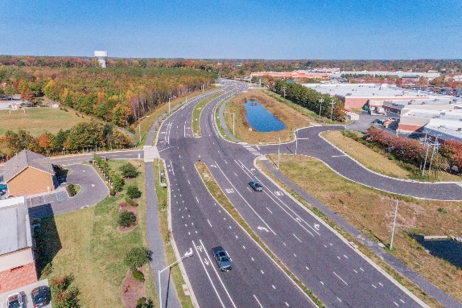  Figure 22. Left-and right-turn lanes at a two-way stop-controlled intersection. Source: VHB
Safe System Roadway Design Hierarchy Alignment:
Tier 1 - Remove Severe Conflicts | Yes
Tier 2 - Reduce Vehicle Speeds | No
Tier 3 - Manage Conflicts in Time | No
Tier 4 - Increase Attentiveness and Awareness | No

Potential Benefits of Dedicated Left-Turn Lanes:
Number of Sites Treated  (excel tab BCR Template, Column J or excel tab CM Score Template, Column M) | # sites
Service Life of PSC  (excel tab BCR Template, Column G or excel tab CM Score Template, Column I) | # years
Number of Intersection Fatalities in Past 5 Years  (Input local data) | #
Number of Intersection Injuries in Past 5 Years  (Input local data) | #
Potential Serious Injuries Prevented over Service Life  (excel tab BCR Template, Column N or excel tab CM Score Template, Column Q) | #
Potential Lives Saved over Service Life  (excel tab BCR Template, Column M or excel tab CM Score Template, Column P) | #
Estimated Cumulative Benefit  (excel tab BCR Template, Column K or excel tab CM Score Template, Column R) | $#
(BCR/CM tab, column J/M) sites – $(column K/R) over (column G/I) years
Potential $# return per $1 spent (BCR Template tab, Column C or CM Score Template tab, Column S)

Dedicated Right-Turn Lanes at Intersections
Auxiliary turn lanes for right turns provide physical separation between turning traffic that is slowing or stopped and adjacent through traffic at approaches to intersections. Turn lanes can be designed to provide for deceleration prior to a turn, as well as for storage of vehicles that are stopped and waiting for the opportunity to complete a turn.  Installing right-turn lanes can provide safety benefits for major road approaches at both three- and four-leg intersections with stop control on the minor road, where significant turning volumes exist, or where there is a history of turn-related crashes. |  | Figure 23. Left-and right-turn lanes at a two-way stop-controlled intersection. Source: VHB
Safe System Roadway Design Hierarchy Alignment:
Tier 1 - Remove Severe Conflicts | Yes
Tier 2 - Reduce Vehicle Speeds | No
Tier 3 - Manage Conflicts in Time | No
Tier 4 - Increase Attentiveness and Awareness | No

Potential Benefits of Dedicated Right-Turn Lanes:
Number of Sites Treated  (excel tab BCR Template, Column J or excel tab CM Score Template, Column M) | # sites
Service Life of PSC  (excel tab BCR Template, Column G or excel tab CM Score Template, Column I) | # years
Number of Intersection Fatalities in Past 5 Years  (Input local data) | #
Number of Intersection Serious Injuries in Past 5 Years  (Input local data) | #
Potential Serious Injuries Prevented over Service Life  (excel tab BCR Template, Column N or excel tab CM Score Template, Column Q) | #
Potential Lives Saved over Service Life  (excel tab BCR Template, Column M or excel tab CM Score Template, Column P) | #
Estimated Cumulative Benefit  (excel tab BCR Template, Column K or excel tab CM Score Template, Column R) | $#
(BCR/CM tab, column J/M) sites – $(column K/R) over (column G/I) years
Potential $# return per $1 spent (BCR Template tab, Column C or CM Score Template tab, Column S)

Systemic Application of Multiple Low-Cost

Countermeasures at Stop-Controlled Intersections
Systemically deploying multiple low-cost treatments to many stop-controlled intersections throughout a jurisdiction can maximize resources and reduce crashes. Examples of common treatments include enhanced pavement markings, retroreflective signpost sheeting, advance warning signs, doubled-up signs, flashing beacons, oversized signs, and sight distance improvements. These countermeasures increase driver awareness and recognition of the intersections and potential conflicts.  There are several benefits to systemically applying multiple low-cost countermeasures at stop-controlled intersections, including:  •Resources are maximized due to low cost of treatments.  •A high number of intersections can receive treatment.  •Improvements are highly cost-effective, with an average benefit-cost ratio of 12:1, even assuming a conservative 3-year service life. |  | 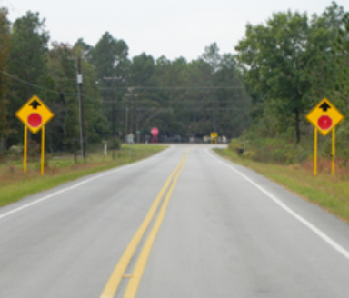  Figure 24. Example of countermeasures on the stop approach. Source: SCDOT
Safe System Roadway Design Hierarchy Alignment:
Tier 1 - Remove Severe Conflicts | No
Tier 2 - Reduce Vehicle Speeds | No
Tier 3 - Manage Conflicts in Time | No
Tier 4 - Increase Attentiveness and Awareness | Yes

Potential Benefits of Systemic Application of Low-Cost Countermeasures:
Number of Sites Treated  (excel tab BCR Template, Column J or excel tab CM Score Template, Column M) |  |  | # sites
Service Life of PSC  (excel tab BCR Template, Column G or excel tab CM Score Template, Column I) |  |  | # years
Number of Intersection Fatalities in Past 5 Years  (Input local data) |  |  | #
Number of Intersection Serious Injuries in Past 5 Years  (Input local data) |  |  | #
Potential Serious Injuries Prevented over Service Life  (excel tab BCR Template, Column N or excel tab CM Score Template, Column Q) |  |  | #
Potential Lives Saved over Service Life  (excel tab BCR Template, Column M or excel tab CM Score Template, Column P) |  |  | #
Estimated Cumulative Benefit  (excel tab BCR Template, Column K or excel tab CM Score Template, Column R) |  |  | $#
(BCR/CM tab, column J/M) sites – $(column K/R) over (column G/I) years
Potential $# return per $1 spent (BCR Template tab, Column C or CM Score Template tab, Column S)

Backplates with Retroreflective Borders
Backplates added to a traffic signal head improve the visibility of the illuminated face of the signal by introducing a controlled-contrast background. The improved visibility of a signal head with a backplate is made even more conspicuous by framing it with a 1- to 3-inch yellow retroreflective border.  Backplates with retroreflective borders are a human factors enhancement that can improve conditions for older and color vision deficient drivers. They also provide safety benefits during power outages because they cue drivers of the presence of an intersection. |  | 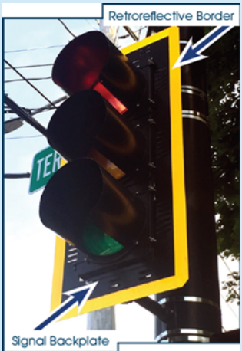  Figure 25. Signal backplate framed with a retroreflective border. Source: FHWA
Safe System Roadway Design Hierarchy Alignment:
Tier 1 – Remove Severe Conflicts | No
Tier 2 – Reduce Vehicle Speeds | No
Tier 3 – Manage Conflicts in Time | No
Tier 4 – Increase Attentiveness and Awareness | Yes

Potential Benefits of Backplates with Retroreflective Borders:
Number of Sites Treated  (excel tab BCR Template, Column J or excel tab CM Score Template, Column M) |  |  | # sites
Service Life of PSC  (excel tab BCR Template, Column G or excel tab CM Score Template, Column I) |  |  | # years
Number of Intersection Fatalities in Past 5 Years  (Input local data) |  |  | #
Number of Intersection Serious Injuries in Past 5 Years  (Input local data) |  |  | #
Potential Serious Injuries Prevented over Service Life  (excel tab BCR Template, Column N or excel tab CM Score Template, Column Q) |  |  | #
Potential Lives Saved over Service Life  (excel tab BCR Template, Column M or excel tab CM Score Template, Column P) |  |  | #
Estimated Cumulative Benefit  (excel tab BCR Template, Column K or excel tab CM Score Template, Column R) |  |  | $#
(BCR/CM tab, column J/M) sites – $(column K/R) over (column G/I) years
Potential $# return per $1 spent (BCR Template tab, Column C or CM Score Template tab, Column S)

Corridor Access Management
Access management refers to the design, application, and control of entry and exit points along a roadway. This includes intersections with other roads and driveways that serve adjacent properties. Thoughtful access management along a corridor can simultaneously enhance safety for all modes, thereby facilitating walking and biking.  The following access management strategies can be used individually or in combination with one another:  • Reduce density through driveway closure, consolidation, or relocation.  • Manage spacing of intersection and access points.  • Limit allowable movements at driveways (such as right-in/right-out only).  • Utilize designs such as roundabouts or reduced left-turn conflicts (such as restricted crossing U-turns, median U-turns, etc.). |  | 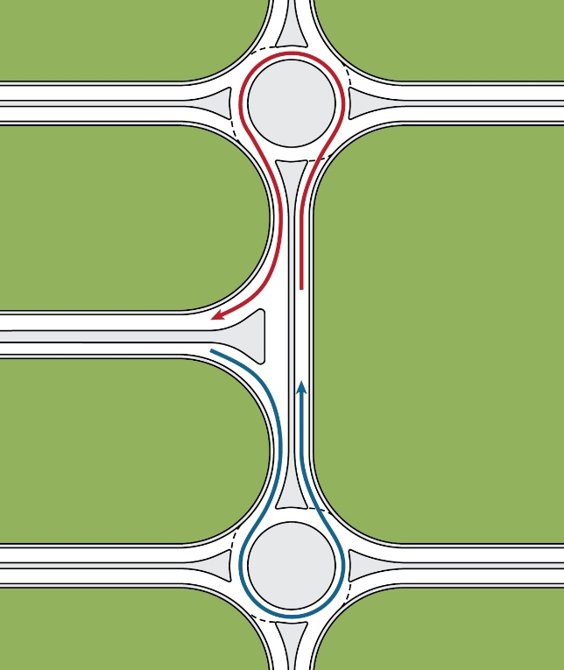  Figure 26. Tandem roundabouts with a continuous raised median eliminates left-turn and across-roadway conflicts. Source: FHWA
Safe System Roadway Design Hierarchy Alignment:
Tier 1 - Remove Severe Conflicts | Yes
Tier 2 - Reduce Vehicle Speeds | No
Tier 3 - Manage Conflicts in Time | No
Tier 4 - Increase Attentiveness and Awareness | No

Potential Benefits of Corridor Access Management:
Number of Sites Treated  (excel tab BCR Template, Column J or excel tab CM Score Template, Column M) |  |  | # sites
Service Life of PSC  (excel tab BCR Template, Column G or excel tab CM Score Template, Column I) |  |  | # years
Number of Intersection Fatalities in Past 5 Years  (Input local data) |  |  | #
Number of Intersection Serious Injuries in Past 5 Years  (Input local data) |  |  | #
Potential Serious Injuries Prevented over Service Life  (excel tab BCR Template, Column N or excel tab CM Score Template, Column Q) |  |  | #
Potential Lives Saved over Service Life  (excel tab BCR Template, Column M or excel tab CM Score Template, Column P) |  |  | #
Estimated Cumulative Benefit  (excel tab BCR Template, Column K or excel tab CM Score Template, Column R) |  |  | $#
(BCR/CM tab, column J/M) sites – $(column K/R) over (column G/I) years
Potential $# return per $1 spent (BCR Template tab, Column C or CM Score Template tab, Column S)

Enhanced Delineation for Horizontal Curves
Improving curve delineation through signage and pavement markings can promote proper vehicle alignment through the curve. There are a wide range of options available for improving horizontal curve delineation in advance of or within curves, either in combination or individually; common treatments include pavement markings, in-lane curve warning pavement markings, retroreflective strips on signposts, delineators (post-mounted or guardrail-mounted), chevrons, improving sign conspicuity (larger, fluorescent, and retroreflective signs), and dynamic warning signs or chevrons. |  | 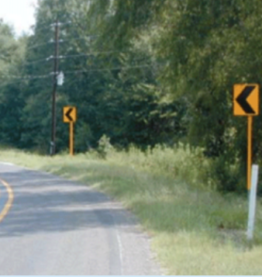  Figure 27. Chevron signs with retroreflective strips on signposts installed along a curve. Source: FHWA
Safe System Roadway Design Hierarchy Alignment:
Tier 1 - Remove Severe Conflicts | No
Tier 2 - Reduce Vehicle Speeds | No
Tier 3 - Manage Conflicts in Time | No
Tier 4 - Increase Attentiveness and Awareness | Yes

Potential Benefits of Enhanced Delineation for Horizontal Curves:
Number of Sites Treated  (excel tab BCR Template, Column J or excel tab CM Score Template, Column M) |  |  | # sites
Service Life of PSC  (excel tab BCR Template, Column G or excel tab CM Score Template, Column I) |  |  | # years
Number of Roadway Departure Fatalities in Past 5 Years  (Input local data) |  |  | #
Number of Roadway Departure Serious Injuries in Past 5 Years  (Input local data) |  |  | #
Potential Serious Injuries Prevented over Service Life  (excel tab BCR Template, Column N or excel tab CM Score Template, Column Q) |  |  | #
Potential Lives Saved over Service Life  (excel tab BCR Template, Column M or excel tab CM Score Template, Column P) |  |  | #
Estimated Cumulative Benefit  (excel tab BCR Template, Column K or excel tab CM Score Template, Column R) |  |  | $#
(BCR/CM tab, column J/M) sites – $(column K/R) over (column G/I) years
Potential $# return per $1 spent (BCR Template tab, Column C or CM Score Template tab, Column S)

Variable Speed Limits
Drivers typically determine their operating speeds under normal weather conditions on a straight roadway section with good pavement quality and adequate sight distances. Providing variable speeds limits (VSLs) capable of adapting to changing circumstances can reduce crash frequency and severity when ideal conditions do not exist and the roadway does not meet the driver’s expectations.  Agencies can implement VSLs for congestion, incidents, work zones, and inclement weather. They are effective on urban and rural freeways and high-speed arterials and can mitigate rear-end, sideswipe, and other crashes on high-speed roadways. |  | 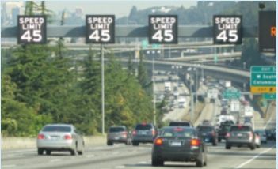  Figure 28. Variable speed limit signs posted over a highway. Source: WSDOT
Safe System Roadway Design Hierarchy Alignment:
Tier 1 - Remove Severe Conflicts | No
Tier 2 - Reduce Vehicle Speeds | Yes
Tier 3 - Manage Conflicts in Time | No
Tier 4 - Increase Attentiveness and Awareness | Yes

Potential Benefits of Variable Speed Limits:
Number of Sites Treated  (excel tab BCR Template, Column J or excel tab CM Score Template, Column M) | # sites
Service Life of PSC  (excel tab BCR Template, Column G or excel tab CM Score Template, Column I) | # years
Number of Speeding Fatalities in Past 5 Years  (Input local data) | #
Number of Speeding Serious Injuries in Past 5 Years  (Input local data) | #
Potential Serious Injuries Prevented over Service Life  (excel tab BCR Template, Column N or excel tab CM Score Template, Column Q) | #
Potential Lives Saved over Service Life  (excel tab BCR Template, Column M or excel tab CM Score Template, Column P) | #
Estimated Cumulative Benefit  (excel tab BCR Template, Column K or excel tab CM Score Template, Column R) | $#
(BCR/CM tab, column J/M) sites – $(column K/R) over (column G/I) years
Potential $# return per $1 spent (BCR Template tab, Column C or CM Score Template tab, Column S)

Appropriate Speed Limits
Setting speed limits that are consistent and reasonable for local conditions is critical for effectively managing travel speeds and reducing crash severity. When setting speed limits, agencies should consider non-vehicular activities, types of road users present, crash history, land use context, traffic volumes, and observed speeds, among other factors.  An effective speed management program uses multiple strategies concurrently with setting speed limits, such as traffic calming features, design features, high-visibility enforcement, and speed safety cameras, that encourage compliance with the posted speed limit. |  | 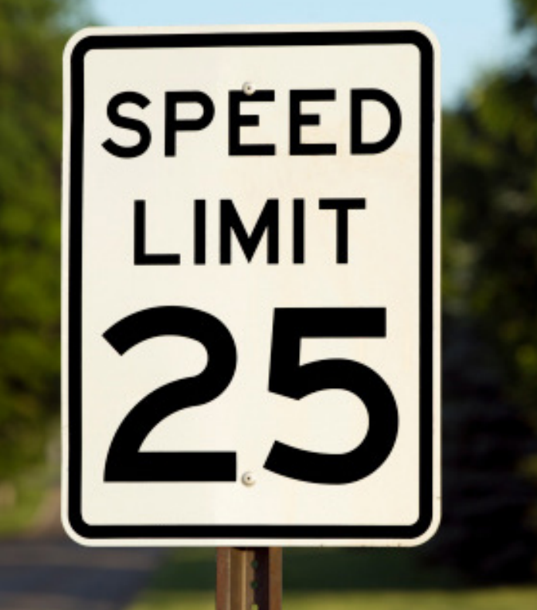  Figure 29. Posted speed limit sign. Source: Getty Images
Safe System Roadway Design Hierarchy Alignment:
Tier 1 - Remove Severe Conflicts | No
Tier 2 - Reduce Vehicle Speeds | Yes
Tier 3 - Manage Conflicts in Time | No
Tier 4 - Increase Attentiveness and Awareness | No

Potential Benefits of Appropriate Speed Limits:
Number of Sites Treated  (excel tab BCR Template, Column J or excel tab CM Score Template, Column M) | # sites
Service Life of PSC  (excel tab BCR Template, Column G or excel tab CM Score Template, Column I) | # years
Number of Speeding Fatalities in Past 5 Years  (Input local data) | #
Number of Speeding Serious Injuries in Past 5 Years  (Input local data) | #
Potential Serious Injuries Prevented over Service Life  (excel tab BCR Template, Column N or excel tab CM Score Template, Column Q) | #
Potential Lives Saved over Service Life  (excel tab BCR Template, Column M or excel tab CM Score Template, Column P) | #
Estimated Cumulative Benefit  (excel tab BCR Template, Column K or excel tab CM Score Template, Column R) | $#
(BCR/CM tab, column J/M) sites – $(column K/R) over (column G/I) years
Potential $# return per $1 spent (BCR Template tab, Column C or CM Score Template tab, Column S)

Lighting: Intersections
Nighttime driving accounts for approximately 25 percent of total vehicle miles traveled annually nationwide, but the nighttime crash fatality rate is roughly 3 times higher than the daytime rate.  Increased visibility at intersections at nighttime is important since various modes of travel cross paths at these locations. Agencies should consider providing lighting to intersections based on factors such as a history of crashes at nighttime, traffic volume, the volume of non-motorized users, the presence of crosswalks and raised medians, and the presence of transit stops and boarding volumes. |  | 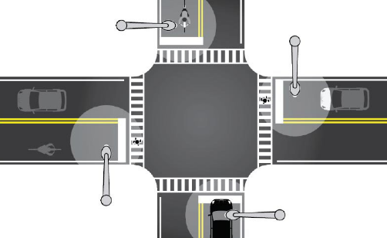  Figure 30. Intersection lighting at all four approaches of an intersection. Source: FHWA
Safe System Roadway Design Hierarchy Alignment:
Tier 1 - Remove Severe Conflicts | No
Tier 2 - Reduce Vehicle Speeds | No
Tier 3 - Manage Conflicts in Time | No
Tier 4 - Increase Attentiveness and Awareness | Yes

Potential Benefits of Intersection Lighting:
Number of Sites Treated  (excel tab BCR Template, Column J or excel tab CM Score Template, Column M) | # sites
Service Life of PSC  (excel tab BCR Template, Column G or excel tab CM Score Template, Column I) | # years
Number of Nighttime Fatalities in Past 5 Years  (Input local data) | #
Number of Nighttime Serious Injuries in Past 5 Years  (Input local data) | #
Potential Serious Injuries Prevented over Service Life  (excel tab BCR Template, Column N or excel tab CM Score Template, Column Q) | #
Potential Lives Saved over Service Life  (excel tab BCR Template, Column M or excel tab CM Score Template, Column P) | #
Estimated Cumulative Benefit  (excel tab BCR Template, Column K or excel tab CM Score Template, Column R) | $#
(BCR/CM tab, column J/M) sites – $(column K/R) over (column G/I) years
Potential $# return per $1 spent (BCR Template tab, Column C or CM Score Template tab, Column S)

Lighting: Segments
Nighttime driving accounts for approximately 25 percent of total vehicle miles traveled annually nationwide, but the nighttime crash fatality rate is roughly 3 times higher than the daytime rate.  At nighttime, vehicles traveling at higher speeds may not have the ability to stop once a hazard or change in the road ahead becomes visible by the headlights. Therefore, lighting can be applied continuously along segments to reduce the chances of a crash. |  | 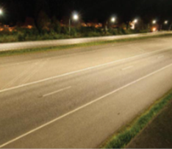  Figure 311. A section of roadway with nighttime lighting. Source: WSDOT
Safe System Roadway Design Hierarchy Alignment:
Tier 1 - Remove Severe Conflicts | No
Tier 2 - Reduce Vehicle Speeds | No
Tier 3 - Manage Conflicts in Time | No
Tier 4 - Increase Attentiveness and Awareness | Yes

Potential Benefits of Roadway Segment Lighting:
Number of Sites Treated  (excel tab BCR Template, Column J or excel tab CM Score Template, Column M) | # sites
Service Life of PSC  (excel tab BCR Template, Column G or excel tab CM Score Template, Column I) | # years
Number of Nighttime Fatalities in Past 5 Years  (Input local data) | #
Number of Nighttime Serious Injuries in Past 5 Years  (Input local data) | #
Potential Serious Injuries Prevented over Service Life  (excel tab BCR Template, Column N or excel tab CM Score Template, Column Q) | #
Potential Lives Saved over Service Life  (excel tab BCR Template, Column M or excel tab CM Score Template, Column P) | #
Estimated Cumulative Benefit  (excel tab BCR Template, Column K or excel tab CM Score Template, Column R) | $#
(BCR/CM tab, column J/M) sites – $(column K/R) over (column G/I) years
Potential $# return per $1 spent (BCR Template tab, Column C or CM Score Template tab, Column S)

Speed Safety Cameras (SSCs)
Agencies can use speed safety cameras (SSCs) as an effective and reliable technology to supplement more traditional methods of enforcement, engineering measures, and education to alter the social norms of speeding. SSCs use speed measurement devices to detect speeding and capture photographic or video evidence of vehicles that are violating a set speed threshold.  As part of a cohesive speed management program, speed safety cameras can be deployed as fixed, point-to-point, or mobile units and can help reduce speeding behaviors, especially in school and work zones.  SSCs can be deployed as:  • Fixed units—a single, stationary camera targeting one location.  • Point-to-Point (P2P) units—multiple cameras to capture average speed over a certain distance.  • Mobile units—a portable camera, generally in a vehicle or trailer |  | 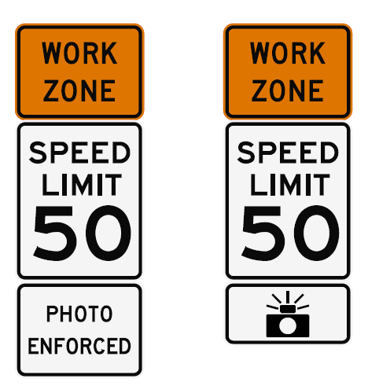  Figure 32. Work zone SSC signage. Source: FHWA
Safe System Roadway Design Hierarchy Alignment:
Tier 1 - Remove Severe Conflicts | No
Tier 2 - Reduce Vehicle Speeds | Yes
Tier 3 - Manage Conflicts in Time | No
Tier 4 - Increase Attentiveness and Awareness | No

Potential Benefits of SSCs:
Number of Sites Treated  (excel tab BCR Template, Column J or excel tab CM Score Template, Column M) |  |  | # sites
Service Life of PSC  (excel tab BCR Template, Column G or excel tab CM Score Template, Column I) |  |  | # years
Number of Speeding Fatalities in Past 5 Years  (Input local data) |  |  | #
Number of Speeding Serious Injuries in Past 5 Years  (Input local data) |  |  | #
Potential Serious Injuries Prevented over Service Life  (excel tab BCR Template, Column N or excel tab CM Score Template, Column Q) |  |  | #
Potential Lives Saved over Service Life  (excel tab BCR Template, Column M or excel tab CM Score Template, Column P) |  |  | #
Estimated Cumulative Benefit  (excel tab BCR Template, Column K or excel tab CM Score Template, Column R) |  |  | $#
(BCR/CM tab, column J/M) sites – $(column K/R) over (column G/I) years
Potential $# return per $1 spent (BCR Template tab, Column C or CM Score Template tab, Column S)

Walkways
A walkway is any type of defined space or pathway for use by a person traveling by foot or using a wheelchair. These may include roadway shoulders, shared use paths, sidewalks, or dedicated pedestrian pathways.  Well-designed pedestrian walkways, shared use paths, and sidewalks improve the safety and mobility of pedestrians.  Accessible walkways may be especially useful along both sides of the road in urban areas, particularly near school zones and transit locations, and where there is a large amount of pedestrian activity. |  | 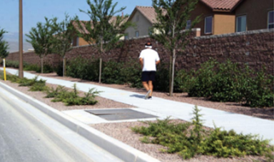  Figure 33. Example of a sidewalk in a residential area. Source: pedbikeimages.org/Burden
Safe System Roadway Design Hierarchy Alignment:
Tier 1 - Remove Severe Conflicts | Yes
Tier 2 - Reduce Vehicle Speeds | No
Tier 3 - Manage Conflicts in Time | No
Tier 4 - Increase Attentiveness and Awareness | No

Potential Benefits of Walkways:
Number of Sites Treated  (excel tab BCR Template, Column J or excel tab CM Score Template, Column M) |  |  | # sites
Service Life of PSC  (excel tab BCR Template, Column G or excel tab CM Score Template, Column I) |  |  | # years
Number of Pedestrian Fatalities in Past 5 Years  (Input local data) |  |  | #
Number of Pedestrian Serious Injuries in Past 5 Years  (Input local data) |  |  | #
Potential Serious Injuries Prevented over Service Life  (excel tab BCR Template, Column N or excel tab CM Score Template, Column Q) |  |  | #
Potential Lives Saved over Service Life  (excel tab BCR Template, Column M or excel tab CM Score Template, Column P) |  |  | #
Estimated Cumulative Benefit  (excel tab BCR Template, Column K or excel tab CM Score Template, Column R) |  |  | $#
(BCR/CM tab, column J/M) sites – $(column K/R) over (column G/I) years
Potential $# return per $1 spent (BCR Template tab, Column C or CM Score Template tab, Column S)

Yellow Change Intervals
At a signalized intersection, the yellow change interval is the length of time that the yellow signal indication is displayed following a green signal indication. The yellow signal confirms to motorists that the green has ended and that a red will soon follow.  Red-light running is a leading causal factor for severe crashes at intersections. If the yellow change interval is too short for the travel speeds, drivers will be unable to stop in time; conversely, if the yellow change interval is too long, familiar drivers will treat the yellow phase as an extension of the green phase. |  | 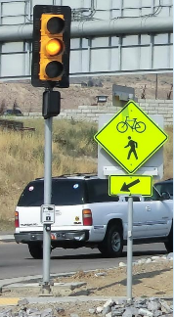  Figure 34. An example of a traffic signal during a yellow change interval. Source: FHWA
Safe System Roadway Design Hierarchy Alignment:
Tier 1 - Remove Severe Conflicts | No
Tier 2 - Reduce Vehicle Speeds | No
Tier 3 - Manage Conflicts in Time | Yes
Tier 4 - Increase Attentiveness and Awareness | No

Potential Benefits of Yellow Change Intervals:
Number of Sites Treated  (excel tab BCR Template, Column J or excel tab CM Score Template, Column M) |  |  | # sites
Service Life of PSC  (excel tab BCR Template, Column G or excel tab CM Score Template, Column I) |  |  | # years
Number of Intersection Fatalities in Past 5 Years  (Input local data) |  |  | #
Number of Intersection Serious Injuries in Past 5 Years  (Input local data) |  |  | #
Potential Serious Injuries Prevented over Service Life  (excel tab BCR Template, Column N or excel tab CM Score Template, Column Q) |  |  | #
Potential Lives Saved over Service Life  (excel tab BCR Template, Column M or excel tab CM Score Template, Column P) |  |  | #
Estimated Cumulative Benefit  (excel tab BCR Template, Column K or excel tab CM Score Template, Column R) |  |  | $#
(BCR/CM tab, column J/M) sites – $(column K/R) over (column G/I) years
Potential $# return per $1 spent (BCR Template tab, Column C or CM Score Template tab, Column S)

Pedestrian Hybrid Beacons (PHBs)
The PHB is a traffic control device designed to help pedestrians safely cross higher-speed roadways at midblock crossings and uncontrolled intersections. As a safety strategy to address this pedestrian crash risk, the PHB is an intermediate option between a flashing beacon and a full pedestrian signal because it assigns right of way and provides positive stop control.  In general, PHBs are used where it is difficult for pedestrians to cross a roadway, such as when gaps in traffic are not sufficient or speed limits exceed 35 miles per hour. They are very effective at locations where three or more lanes will be crossed or traffic volumes are above 9,000 annual average daily traffic. Installation of a PHB must also include a marked crosswalk and pedestrian countdown signal (MUTCD 4J.01). |  | 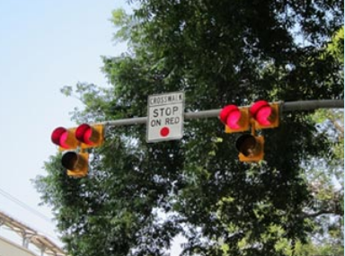  Figure 35. Example of PHBs mounted on a mast arm. Source: FHWA
Safe System Roadway Design Hierarchy Alignment:
Tier 1 - Remove Severe Conflicts | No
Tier 2 - Reduce Vehicle Speeds | No
Tier 3 - Manage Conflicts in Time | Yes
Tier 4 - Increase Attentiveness and Awareness | No

Potential Benefits of PHBs:
Number of Sites Treated  (excel tab BCR Template, Column J or excel tab CM Score Template, Column M) | # sites
Service Life of PSC  (excel tab BCR Template, Column G or excel tab CM Score Template, Column I) | # years
Number of Pedestrian Fatalities in Past 5 Years  (Input local data) | #
Number of Pedestrian Serious Injuries in Past 5 Years  (Input local data) | #
Potential Serious Injuries Prevented over Service Life  (excel tab BCR Template, Column N or excel tab CM Score Template, Column Q) | #
Potential Lives Saved over Service Life  (excel tab BCR Template, Column M or excel tab CM Score Template, Column P) | #
Estimated Cumulative Benefit  (excel tab BCR Template, Column K or excel tab CM Score Template, Column R) | $#
(BCR/CM tab, column J/M) sites – $(column K/R) over (column G/I) years
Potential $# return per $1 spent (BCR Template tab, Column C or CM Score Template tab, Column S)

Local Road Safety Plans (LRSP)
An LRSP provides a framework for identifying, analyzing, and prioritizing roadway safety improvements on all local and Tribal roads within a jurisdiction. The successful development of an LRSP engages multiple stakeholders, uses a data-driven approach, and results in a list of issues, risks, actions, and improvements that are tailored and prioritized based on local needs to aid agencies in reducing fatalities and serious injuries on their road network.  While local roads are less traveled than State highways, they have a much higher rate of fatal and serious injury crashes. Developing an LRSP is an effective strategy to improve local road safety for all road users and can support the goals of a State’s overall Strategic Highway Safety Plan (SHSP), while being updated to reflect changing local needs and priorities. |  | 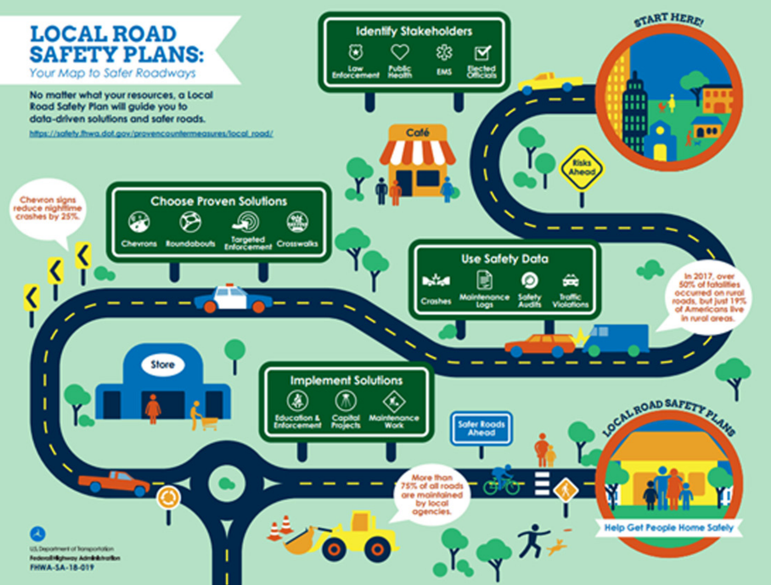  Figure 36. LSRP Infographic. Source: FHWA
Safe System Roadway Design Hierarchy Alignment:
Tier 1 - Remove Severe Conflicts | Yes
Tier 2 - Reduce Vehicle Speeds | Yes
Tier 3 - Manage Conflicts in Time | Yes
Tier 4 - Increase Attentiveness and Awareness | Yes

Potential Benefits of LRSPs:
Number of Sites Treated  (excel tab BCR Template, Column J or excel tab CM Score Template, Column M) |  |  | # sites
Service Life of PSC  (excel tab BCR Template, Column G or excel tab CM Score Template, Column I) |  |  | # years
Number of All Roadway Fatalities in Past 5 Years  (Input local data) |  |  | #
Number of All Roadway Serious Injuries in Past 5 Years  (Input local data) |  |  | #
Potential Serious Injuries Prevented over Service Life  (excel tab BCR Template, Column N or excel tab CM Score Template, Column Q) |  |  | #
Potential Lives Saved over Service Life  (excel tab BCR Template, Column M or excel tab CM Score Template, Column P) |  |  | #
Estimated Cumulative Benefit  (excel tab BCR Template, Column K or excel tab CM Score Template, Column R) |  |  | $#
(BCR/CM tab, column J/M) sites – $(column K/R) over (column G/I) years
Potential $# return per $1 spent (BCR Template tab, Column C or CM Score Template tab, Column S)

Road Safety Audit (RSA)
While most transportation agencies have established traditional safety review procedures, a road safety audit (RSA) or assessment is unique. RSAs are performed by a multidisciplinary team independent of the project. RSAs consider all road users, account for human factors and road user capabilities, are documented in a formal report, and require a formal response from the road owner.  RSAs can be performed in any phase of project development, from planning through construction. Agencies may focus RSAs specifically on motorized vehicles, pedestrians, bicyclists, motorcyclists, or a combination of these roadway users. Agencies are encouraged to conduct an RSA at the earliest stage possible. |  | 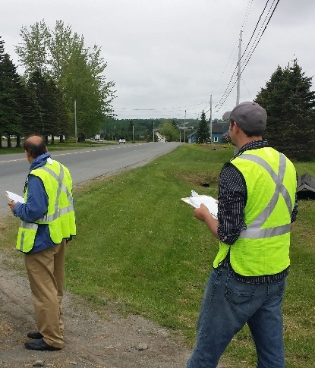  Figure 37. Multi-disciplinary team performs field review during an RSA. Source: FHWA
Safe System Roadway Design Hierarchy Alignment:
Tier 1 - Remove Severe Conflicts | Yes
Tier 2 - Reduce Vehicle Speeds | Yes
Tier 3 - Manage Conflicts in Time | Yes
Tier 4 - Increase Attentiveness and Awareness | Yes

Potential Benefits of RSAs:
Number of Sites Treated  (excel tab BCR Template, Column J or excel tab CM Score Template, Column M) | # sites
Service Life of PSC  (excel tab BCR Template, Column G or excel tab CM Score Template, Column I) | # years
Number of All Roadway Fatalities in Past 5 Years  (Input local data) | #
Number of All Roadway Serious Injuries in Past 5 Years  (Input local data) | #
Potential Serious Injuries Prevented over Service Life  (excel tab BCR Template, Column N or excel tab CM Score Template, Column Q) | #
Potential Lives Saved over Service Life  (excel tab BCR Template, Column M or excel tab CM Score Template, Column P) | #
Estimated Cumulative Benefit  (excel tab BCR Template, Column K or excel tab CM Score Template, Column R) | $#
(BCR/CM tab, column J/M) sites – $(column K/R) over (column G/I) years
Potential $# return per $1 spent (BCR Template tab, Column C or CM Score Template tab, Column S)



Proven Safety Countermeasures

