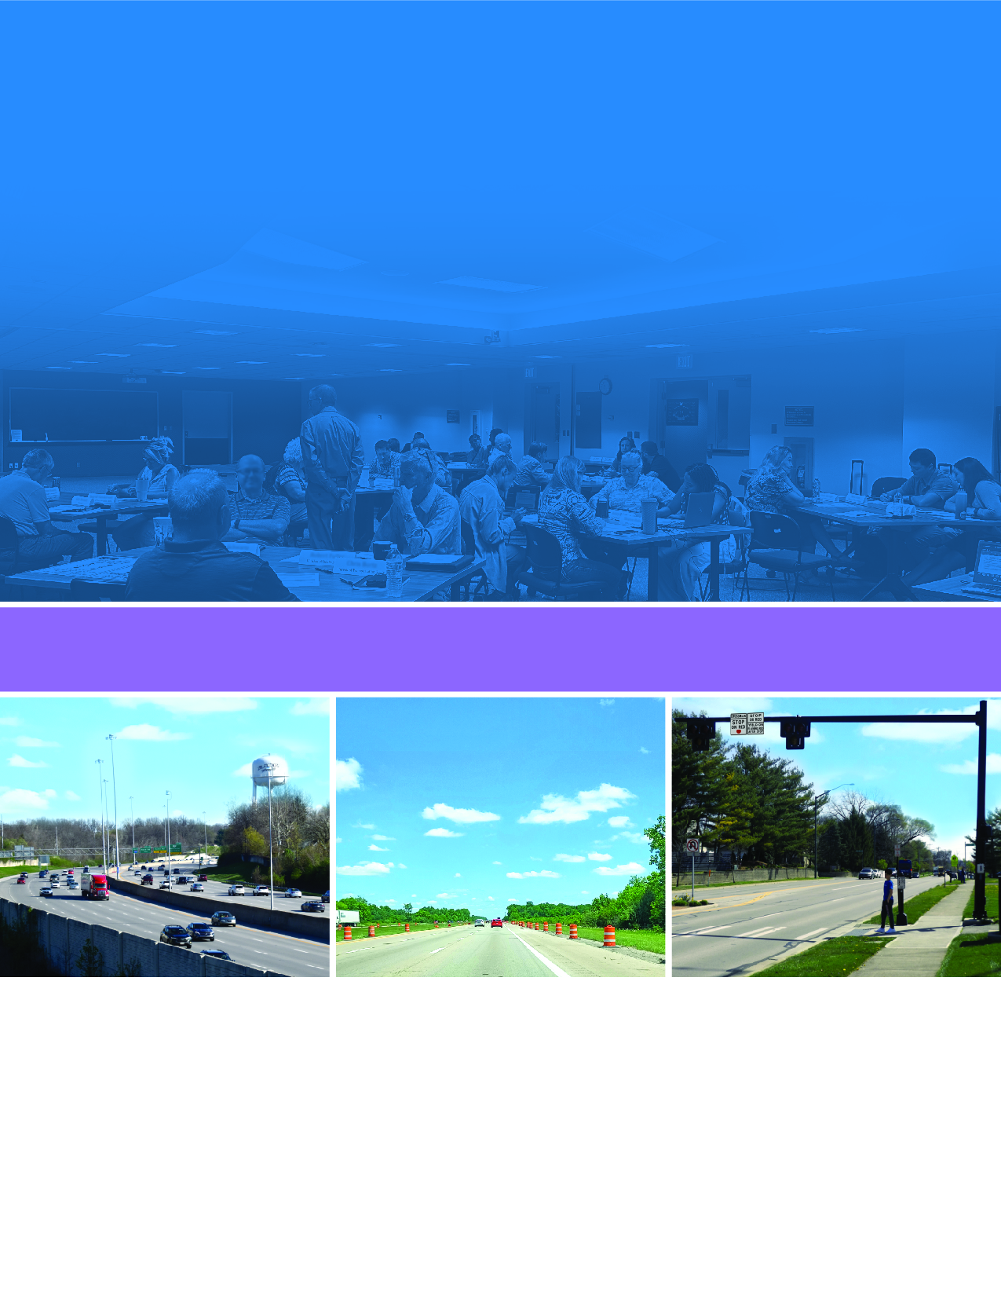
Organizational Safety Culture Self-Assessment for Transportation Agencies
Improvement Plan Template
Photos Source: FHWA
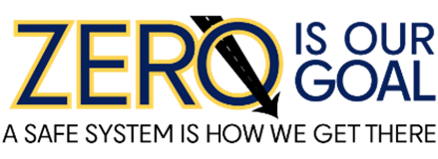
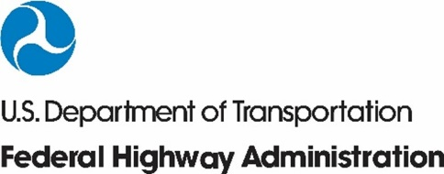
FHWA-SA-24-029

Notice
This document is disseminated under the sponsorship of the U.S. Department of Transportation in the interest of information exchange. The U.S. Government assumes no liability for the use of the information contained in this document.
Non-Binding Contents
Except for the statutes and regulations cited, the contents of this document do not have the force and effect of law and are not meant to bind the States or the public in any way. This document is intended only to provide information regarding existing requirements under the law or agency policies.
Quality Assurance Statement
The Federal Highway Administration (FHWA) provides high-quality information to serve Government, industry, and the public in a manner that promotes public understanding. Standards and policies are used to ensure and maximize the quality, objectivity, utility, and integrity of its information. FHWA periodically reviews quality issues and adjusts its programs and processes to ensure continuous quality improvement.
Disclaimer for Product Names and Manufacturers
The U.S. Government does not endorse products or manufacturers. Trademarks or manufacturers’ names appear in this document only because they are considered essential to the objective of the document. They are included for informational purposes only and are not intended to reflect a preference, approval, or endorsement of any one product or entity.

Technical Report Documentation Page
1. Report No.  FHWA-SA-24-029 | 2. Government Accession No. |  | 3. Recipient's Catalog No.
4. Title and Subtitle  Organizational Safety Culture Self-Assessment for Transportation Agencies –Improvement Plan Template |  |  | 5. Report Date  June 2024
 |  |  | 6. Performing Organization Code
7. Author(s)  Jay Otto, Ashley Robertson, Alan Pate, Hunter McCracken, Jaime Sullivan, Nicholas Ward |  |  | 8. Performing Organization Report No.
9. Performing Organization Name and Address  Battelle Center for Health and Safety Culture Guidehouse  505 King Avenue Montana State University 1800 Tysons Blvd.  Columbus, OH 43201 2327 University Way Mclean, VA 22102  Bozeman, MT 59715 |  |  | 10. Work Unit No. (TRAIS)
11. Contract or Grant No.
DTFH6116D00049 / 693JJ320F000374
DTFH6116D00049 / 693JJ322F00407N
DTFH6116D00049 / 693JJ323F00242N
12. Sponsoring Agency Name and Address  Federal Highway Administration  Office of Operations  1200 New Jersey Avenue SE  Washington, DC 20590 |  |  | 13. Type of Report and Period Covered  Final Report  September 2020 – June 2024
14. Sponsoring Agency Code
HSA
15. Supplementary Notes
FHWA staff overseeing the work were: Chimai Ngo (Task Order Contracting Officer’s Representative), Felix Delgado, Phillip Bobitz, and Jim Thorne
16. Abstract
Safety is the very foundation of every transportation agency’s mission and enables the safe and efficient movement of road users across the country. While all transportation agencies (from State departments of transportation, to local, regional, and Tribal governments, to transit agencies) strive to guarantee safety for both their users and workers, their approaches to doing so vary widely. Agencies span a range of capability and maturity levels in building a strong safety culture within their agency, as well as levels of investment in their programs, technologies, and resources to enable safety policies and practices. The Federal Highway Administration is developing a toolkit specifically geared toward organizational road safety culture, including both road safety and programmatic safety. The goal of the toolkit will be to focus transportation agency resources and actions to systematically improve an agency’s organizational road safety culture. This report contains a template for organizations to use when developing an improvement plan.
17. Key Words  Safety culture, road safety culture, traffic safety culture, programmatic safety integration |  | 18. Distribution Statement  No restrictions.
19. Security Classif.(of this report)  Unclassified | 20. Security Classif.(of this page)  Unclassified |  | 21. No. of Pages  26 | 22. Price  N/A
Form DOT F 1700.7 (8-72) Reproduction of completed page authorized

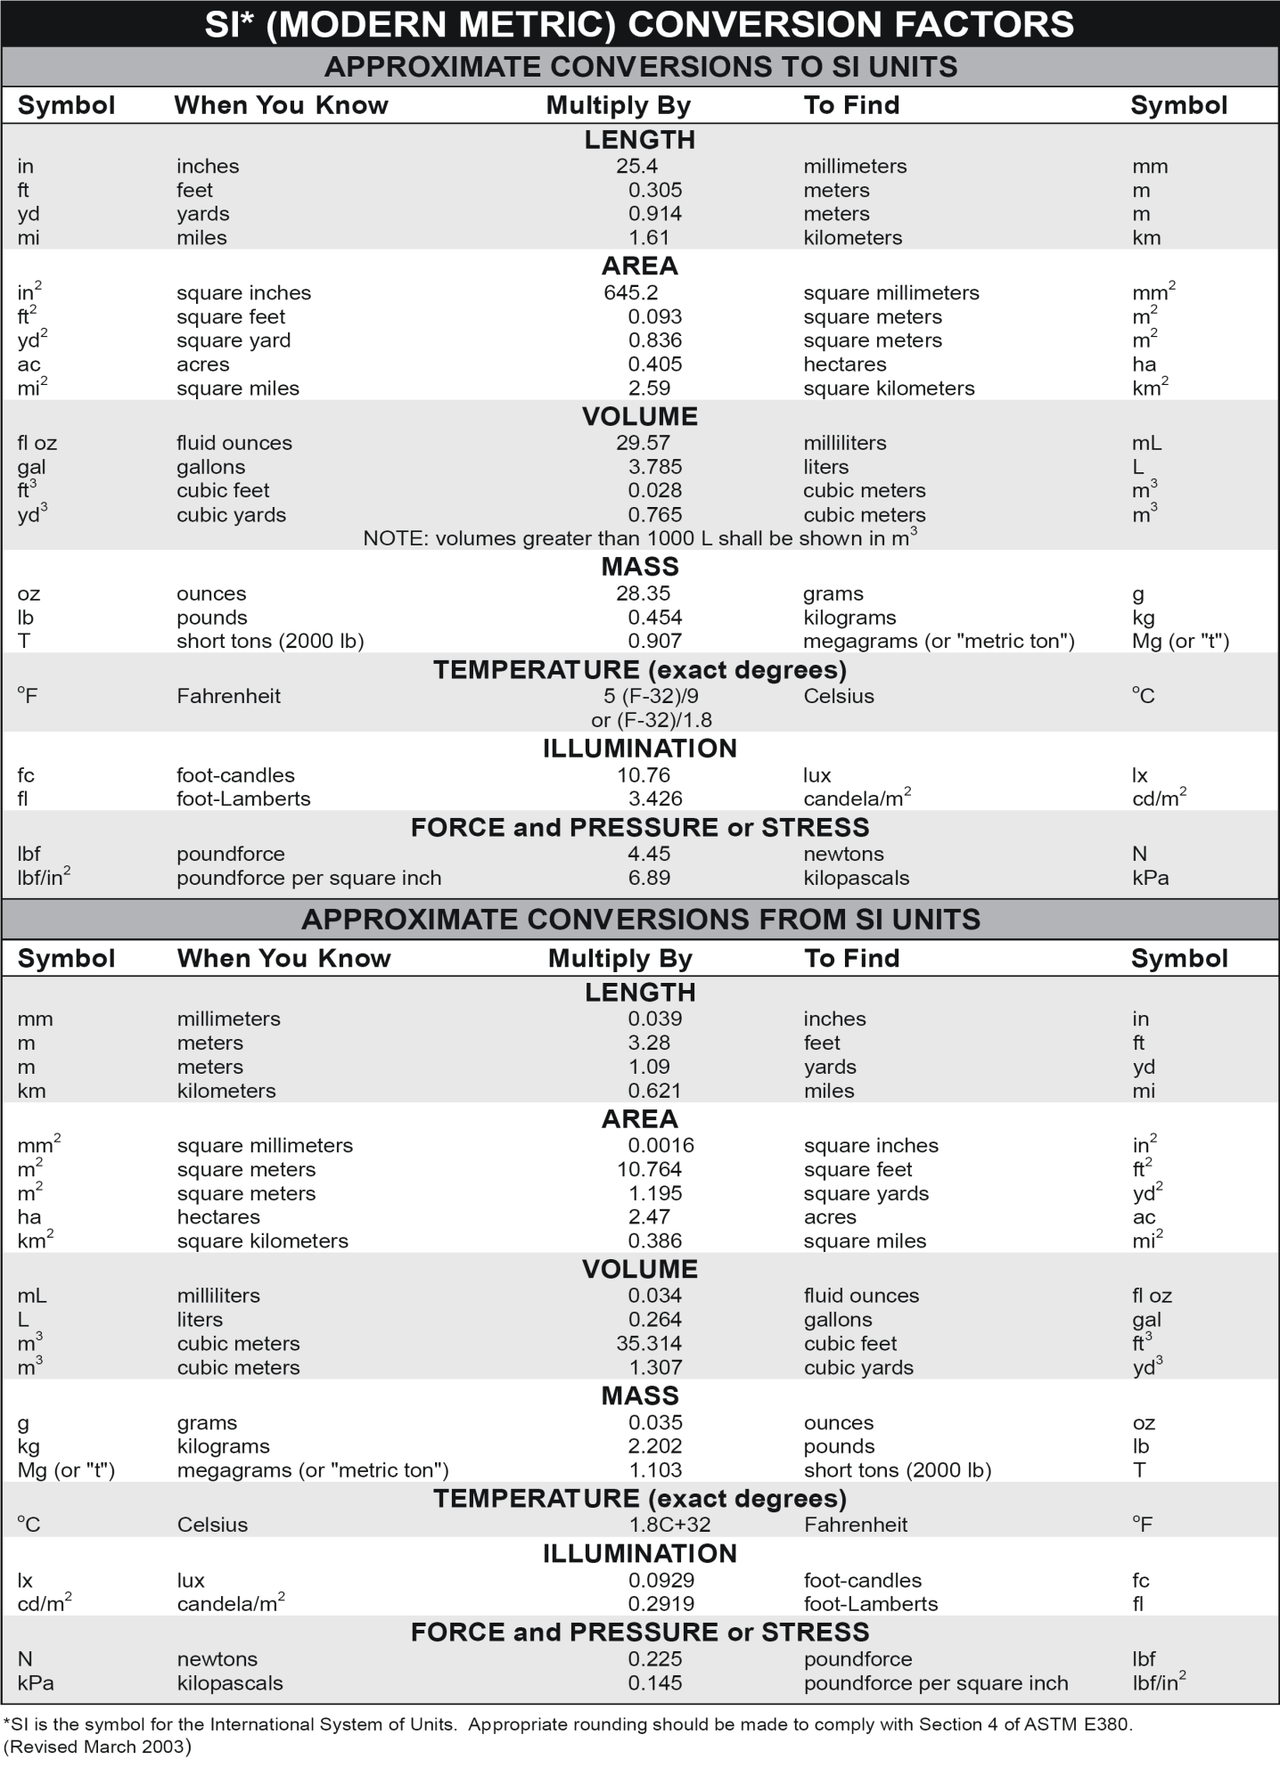
Table of Contents
INTRODUCTION 1
IMPROVEMENT PLAN TEMPLATE 2
Internal Safety Culture 4
Improvement Plan 4
Maturity Level Summary 5
Programmatic Safety Integration 8
Improvement Plan 8
Maturity Level Summary 9
APPENDIX A: EXAMPLE IMPROVEMENT PLAN 14
APPENDIX B: EXAMPLE MATURITY LEVEL SUMMARY 17

LIST OF ACRONYMS
DOT Department of Transportation
FHWA Federal Highway Administration

INTRODUCTION
Although the transportation community has made significant safety improvements in the past decade, there is still much work to be done to keep the roads safe for all users of the transportation system. Thanks to the Safe System Approach, we remind ourselves that safety is a shared responsibility and safety commitment should start at “home”—within an organization.
Safety can be defined as the absence of risk or danger. Road safety culture includes the shared values, actions, and behaviors that demonstrate a commitment to safety over competing goals and demands. Organizational road safety culture is one of two major aspects of road safety culture (the other aspect is public road safety culture). It is the extent to which an organization values and pursues road safety. In an organization that prioritizes organizational road safety culture, the organization emphasizes safety in its internal strategic plan and operation procedures and its employees make safe decisions when using the roads. Furthermore, in a transportation organization with a strong organizational road safety culture, employees understand safety as a priority and have safety in mind when planning, designing, constructing, and maintaining the road system. Employees regularly communicate the importance of road safety with colleagues. Leadership staff are vocal supporters of safety and empower employees to seek innovative approaches to improving safety even if safety is not explicitly a part of everyone’s job title.
The Federal Highway Administration (FHWA) developed a toolkit for transportation organizations like yours to determine the organization’s maturity level (i.e., degree of capability or readiness) of organizational road safety culture and identify opportunities for improvements. The goal of the toolkit is to focus transportation agency resources and actions to systematically improve an agency’s organizational road safety culture.
There are two parts of organizational road safety culture: internal safety culture and programmatic safety integration. With that in mind, the toolkit components are divided into these two focus areas.
Each focus area’s self-assessment has three components:
- Questionnaires: Two questionnaires that organizations can use to determine their levels of maturity across a variety of areas.
- Improvement Strategies: Example improvement strategies that organizations can use to advance their level of maturity for each area.
- Improvement Plan Template: Template that organizations can use as a basis for developing a plan to implement their improvement strategies.
In addition, there are two companion documents: 1) a list of resources related to road safety culture; and 2) an instruction manual for using the toolkit.
This document contains the Improvement Plan Template only. See the full toolkit for the other components and companion documents.

IMPROVEMENT PLAN TEMPLATE
Now that your organization has completed the questionnaire and determined your maturity level for each question (see the Questionnaires document), as well as identified possible improvement strategies that your organization plans to implement to advance to the next highest or desired maturity level (see the Improvement Strategies document), it is time to develop an improvement plan that captures the selected strategies and implementation information. This document contains a template for the improvement plan that your organization can adapt and adjust to meet your needs. If your organization has a standard planning process or tool, it can be used instead of this template.
The template includes a cover page containing relevant information and introductory language about the improvement plan, separate Improvement Plan forms for capturing the selected Internal Safety Culture strategies and the selected Programmatic Safety Integration strategies, and a Maturity Level Summary to summarize questionnaire responses.
Using the Template
- Complete the Maturity Level Summary by transferring the “Existing” maturity level for each question to the grid. Discuss and select a “Desired” maturity level for each question. This summary will serve as a quick reference guide as you complete the Improvement Plans.
- Use the Improvement Plan form to document the improvement strategies selected by your organization for each question (duplicate the table for each question). Notate your organization’s “Existing” and "Desired” maturity level for that question using the Maturity Level Summary as a reference. Identify a champion to drive implementation of improvements specific to the corresponding question.
- List the improvement strategies your organization selected for each question in the table. For each strategy, identify the status; key staff; stakeholders that may serve as collaborators; a target completion date; a start date; metrics for measuring progress; and any additional notes relevant to implementation.
Examples of a completed first page of an Improvement Plan for one question and a Maturity Level Summary are provided in Appendix A and Appendix B, respectively.
Next Steps
The purpose of the improvement planning process is to move your organization from assessment into action. Once the improvement plans are complete, coordinate with other groups in your organization to determine an approach for advancing each action. To foster accountability and maintain momentum, your organization may wish to establish regular check-ins to track progress toward advancing the maturity of each dimension.

[Fill out the information below]
Organization: ___________________________________________________________________________________________
Authors: ___________________________________________________________________________________________
Date: ___________________________________________________________________________________________
[Provide introductory language (i.e., a couple paragraphs) describing the current state of organizational road safety culture within your organization and the expectations for how advancing its maturity will benefit the organization.]
The remainder of this document details the organization’s existing and desired maturity levels as well as specific improvement strategies that [ABC Department of Transportation] plans to implement to enhance its organizational road safety culture. Separate information is provided for the two types of organizational road safety culture: Internal Safety Culture and Programmatic Safety Integration.
Champions, key staff, and timelines are identified for the improvement strategies. It is important that all members of the organization contribute to the efforts, as well.

Internal Safety Culture

Improvement Plan
[Duplicate this page for each question for which your organization identified improvement strategies to implement.]
[Fill out the information below]
Dimension: ___________________________________________________________________________________________
Question: ___________________________________________________________________________________________
Existing Maturity Level: ___________________________________________________________________________________
Desired Maturity Level: ___________________________________________________________________________________
Champion: ___________________________________________________________________________________________

# | Improvement Strategy | Status | Key Staff | Key Stakeholders or Collaborators | Target Completion Date | Start Date | Metrics | Notes
1
2
3

Maturity Level Summary
[Indicate your organization’s existing and desired levels of maturity for each question by entering “Existing” and “Desired” in the appropriate columns.]
Dimension | Question | Maturity Level
Dimension | Question | None | Ad-hoc | Recognized | Mainstreamed | Optimized
1. Leadership | 1. To what degree does your organization prioritize road safety in its core values, strategic plan, and actions?
1. Leadership | 2. To what degree do leaders (i.e., senior leaders, managers, and supervisors) prioritize road safety in their communication and activities?
1. Leadership | 3. To what degree does your organization include safety elements in leadership performance plans and reviews?
2. Policy | 4. To what degree does your organization integrate road safety into employee policies?
2. Policy | 5. To what degree do all employee performance plans and reviews include safety elements?
3. Capacity Building and Training | 6. To what degree does new employee orientation/training address the state of road safety and current safety policies which reaches all new employees in a timely fashion?
3. Capacity Building and Training | 7. To what degree does ongoing training address road safety and road safety policies and reach all employees in a timely fashion?
3. Capacity Building and Training | 8. To what degree does your organization have safety capacity building expertise to provide training, assist with safety policies, engage employees, etc.?
4. Employee Engagement | 9. To what degree do employees (i.e., technical and non-technical staff, safety and non-safety disciplines) promote and actively improve safety?
4. Employee Engagement | 10. To what degree do employees understand their role in promoting safety in their work programs?
4. Employee Engagement | 11. To what degree do employees embrace being a safe road user as part of their shared responsibility for roadway safety?
4. Employee Engagement | 12. To what degree do employees (i.e., technical and non-technical staff, safety and non-safety disciplines) lead or are engaged in road safety efforts in their own communities outside of work?
5. Organizational Commitment to Support Road Safety | 13. To what degree does your organization set the expectation that road safety is elevated/ advanced in all programs?
5. Organizational Commitment to Support Road Safety | 14. To what degree does your organization make road safety equipment available and to what degree do employees use it?
5. Organizational Commitment to Support Road Safety | 15. To what degree does your organization consider safety in equipment/vehicle purchasing (or leasing) decisions?
5. Organizational Commitment to Support Road Safety | 16. To what degree does your organization have an effective organization-wide road safety culture workgroup?
5. Organizational Commitment to Support Road Safety | 17. To what degree does your organization have committees or workgroups dedicated to road safety issues (pedestrians/ bicyclists, speed, Complete Streets, etc.)?

Programmatic Safety Integration

Improvement Plan
[Duplicate this page for each question for which your organization identified improvement strategies to implement.]
[Fill out the information below]
Dimension: ___________________________________________________________________________________________
Question: ___________________________________________________________________________________________
Existing Maturity Level: ___________________________________________________________________________________
Desired Maturity Level: ___________________________________________________________________________________
Champion: ___________________________________________________________________________________________

# | Improvement Strategy | Status | Key Staff | Key Stakeholders or Collaborators | Target Completion Date | Start Date | Metrics | Notes
1
2
3

Maturity Level Summary
[Indicate your organization’s existing and desired levels of maturity for each question by entering “Existing” and “Desired” in the appropriate columns.]
Dimension | Question | Maturity Level
Dimension | Question | None | Ad-hoc | Recognized | Mainstreamed | Optimized
1. Planning and Programming | 1. To what degree does your organization engage external safety professionals and stakeholders to influence planning and programming decisions?
1. Planning and Programming | 2. To what degree does your organization engage internal safety professionals and stakeholders to influence planning and programming decisions?
1. Planning and Programming | 3. To what degree does your organization evaluate safety data and other safety considerations during the planning and programming phase?
1. Planning and Programming | 4. To what degree does your organization apply holistic safety approaches to guide project planning and programming decisions and business processes?
1. Planning and Programming | 5. To what degree does your organization coordinate with other jurisdictions/organizations to identify and incorporate safety goals into other Tribal, Federal, State, regional, and local transportation plans?
1. Planning and Programming | 6. When making planning and programming decisions, to what degree does your organization assess and prioritize projects based on their ability to improve system safety?
1. Planning and Programming | 7. For non-safety projects (e.g., non-HSIP projects), to what degree does your organization allocate and prioritize funding for project components that have the potential to improve safety?
2. Design and Engineering | 8. To what degree does your organization make safety a consideration at every step of the design and engineering phase?
2. Design and Engineering | 9. To what degree does your organization encourage designers to optimize designs for safety and not focus solely on meeting design standards?
2. Design and Engineering | 10. To what degree do organizational policies and procedures encourage and enable designers and engineers to identify and implement effective, low-cost safety improvements?
2. Design and Engineering | 11. To what degree does your organization use data-driven safety analysis methods to determine the current and future safety performance of a project?
2. Design and Engineering | 12. To what degree does your organization employ holistic approaches (e.g., Safe System Approach) when designing projects?
2. Design and Engineering | 13. To what degree does your organization use a process for evaluating and integrating new safety technologies and systems into project design or engineering?
3. Safety and Operations | 14. To what degree does your organization use Intelligent Transportation Systems (ITS) systematically to monitor safety conditions and enable real-time safety management?
3. Safety and Operations | 15. To what degree do organizational policies mandate routine evaluation and maintenance of roadway components that impact safety?
3. Safety and Operations | 16. To what degree do accessible processes exist to allow staff and the public to report safety concerns identified on the roadway or roadside?
3. Safety and Operations | 17. To what degree is the public made aware of mechanisms to report safety concerns identified on the roadway or roadside?
3. Safety and Operations | 18. To what degree does your organization implement safety protocols, proven countermeasures, and/or noteworthy practices in the design and operation of work zones?
3. Safety and Operations | 19. To what degree does your organization use a process for evaluating safety performance in work zones following construction or maintenance projects?
4. Safety Assurance and Evaluations | 20. To what degree does your organization use metrics to evaluate the safety performance of the transportation system?
4. Safety Assurance and Evaluations | 21. To what degree does your organization document and integrate lessons learned and noteworthy practices into future projects as they relate to the performance of safety strategies and countermeasures?
4. Safety Assurance and Evaluations | 22. To what degree does your organization use a system to identify areas of safety concern, evaluate risk, and apply strategies to improve system safety?
5. Institutionalizing Safety | 23. To what degree do existing manuals and specifications across program areas integrate safety?
5. Institutionalizing Safety | 24. To what degree does your organization evaluate, fund, and promote access to safety trainings and certifications for staff?
5. Institutionalizing Safety | 25. To what degree does your organization have dedicated staff responsible for public outreach and relationship building around road safety challenges, safety initiatives, and community concerns?

APPENDIX A: EXAMPLE IMPROVEMENT PLAN

Dimension: _1. Planning and Programming__________________________________________________________________
Question: _1. To what degree does your organization engage external safety professionals and stakeholders to influence planning and programming decisions?_____________________________________________________________
Existing Maturity Level: _2. Recognized_______________________________________________________________________
Desired Maturity Level: _3. Mainstreamed_____________________________________________________________________
Champion: _E. Franklin__________________________________________________________________________________

# | Improvement Strategy | Status | Key Staff | Key Stakeholders or Collaborators | Target Completion Date | Start Date | Metrics | Notes
1 | Integrate external stakeholder engagement activities or checkpoints at regular intervals throughout the planning and programming phase for all projects | Active | F. Hernandez/ O. Polk/ E. Franklin | Planning Dept./ Fire & EMS/ Elmwood Neighborhood Assoc. | 06/06/25 | 05/02/25 | Quarterly meetings | Currently have stakeholder engagement in early project stages and can expand throughout the project lifecycle.
2 | Include a process and communication plan in the current planning and programming processes to integrate external stakeholder feedback. | Pending | L. Frost | Planning Dept. / Communications Dept. | 08/01/25 | 06/13/25 | N/A | Use the communications plan adopted by the sustainability team for their public outreach initiative
3 | Establish a formal committee composed of representatives of diverse external stakeholder groups to be engaged on an on-going basis | On Hold until August 2023 | D. Choi | Planning Dept. / Aville Neighborhood Collective | 10/03/25 | 08/10/25 | Committee comprised of 14 members; Committee meets bi-weekly | Currently meet informally with senior center and school district
4* | Conduct outreach with Youth Leadership Council (YLC) | Active | M. Oppenheimer/ O. Polk | Planning Dept./ YLC | 05/06/25 | 04/07/25 | Project Lead attendance at YLC meetings for the project period | YLC has 14 members and meets once a month at City Hall; Planning Dept. personnel currently support YLC meetings
*This is an example of a unique improvement strategy (i.e., not one listed in the Improvement Strategies document)

APPENDIX B: EXAMPLE MATURITY LEVEL SUMMARY

Dimension | Question | Maturity Level
Dimension | Question | None | Ad-hoc | Recognized | Mainstreamed | Optimized
1. Planning and Programming | 1. To what degree does your organization engage external safety professionals and stakeholders to influence planning and programming decisions? |  |  | Existing | Desired
1. Planning and Programming | 2. To what degree does your organization engage external safety professionals and stakeholders to influence planning and programming decisions? |  |  | Existing | Desired
1. Planning and Programming | 3. To what degree does your organization evaluate safety data and other safety considerations during the planning and programming phase? |  | Existing |  | Desired
1. Planning and Programming | 4. To what degree does your organization apply holistic safety approaches to guide project planning and programming decisions and business processes? |  | Existing | Desired
1. Planning and Programming | 5. To what degree does your organization does your organization coordinate with other jurisdictions/ organizations to identify and incorporate safety goals into other Tribal, Federal, State, regional, and local transportation plans? | Existing | Desired

U.S. Department of Transportation Federal Highway Administration
Office of Safety 1200 New Jersey Avenue, SE
Washington, DC 20590

Office of Safety Website
https://highways.dot.gov/safety
June 2024

https://rspcb.safety.fhwa.dot.gov/RSF/Unit1.aspx

