Version 01-02-2025 **OMB CONTROL NUMBER: 2125-0688  
EXPIRATION DATE: 10/31/2027**

**Paperwork Reduction Act Burden Statement**

A federal agency may not conduct or sponsor, and a person is not required to respond to, nor shall a person be subject to a penalty for failure to comply with a collection of information subject to the requirements of the Paperwork Reduction Act unless that collection of information displays a currently valid OMB Control Number. The OMB Control Number for this information collection is **TBD**. Public reporting for this collection of information is estimated to be approximately 2 hours per response, including the time for reviewing instructions, searching existing data sources, gathering, and maintaining the data needed, completing, and reviewing the collection of information.

All responses to this collection of information are required to obtain or retain a benefit (per 23 USC 202(e)). Send comments regarding this burden estimate or any other aspect of this collection of information, including suggestions for reducing this burden to: Information Collection Clearance Officer, Department of Transportation, Federal Highway Administration, 1200 New Jersey Ave SE, Washington, D.C. 20590.

**Introduction**

Applicants can find practical tools for preparing an application in this “Application Guide.” This guide is organized into these major sections:

1. Decision chart for selecting a category
2. Application Form
3. Requirements for each category
4. Appendix describing the selection criteria

**Instructions**

During an active application period, the application process and all relevant forms can be found at the following website: <https://highways.dot.gov/federal-lands/programs-tribal/safety/funds>

There are four categories for TTPSF. Applicants should start by identifying the appropriate category for their application because the required application materials and selection criteria used to evaluate applications are different for each category. The decision chart on page 3 can help you determine the best category for a project. If you are uncertain which category to choose, request technical assistance by contacting the program manager at [TTPSF@DOT.gov](mailto:TTPSF@DOT.gov). Once the correct category has been identified, reference the corresponding section in this guide and follow those instructions for the application process for that category. The TTPSF categories are:

* Safety Plans Category
* Data Assessment, Improvement, and Analysis Category
* Systemic Roadway Departure Countermeasures Category
* Infrastructure Improvement Category

Application requirements vary by category, as summarized in the following table and detailed later:

|  |  |  |  |  |
| --- | --- | --- | --- | --- |
| **Application Element** | **Safety Plan** | **Data Assessment, Improvement, and Analysis** | **Systemic Roadway Departure Countermeasures** | **Infrastructure Improvement (Design and/or Construction)** |
| Application Form | X | X | X | X |
| Project Narrative |  | X | X | X |
| Safety Plan | For Updates | X |  | X |
| Countermeasure Request Form |  |  | X |  |

Submit completed applications by email to [TTPSF@DOT.gov](mailto:TTPSF@DOT.gov). If an alternative submission method is needed, applicants may contact the program manager using the information in the NOFO. The current program manager, Adam Larsen, can be reached at 360-619-2601 or adam.larsen@dot.gov.

**Table of Contents**

**Introduction and Instructions** 1

**Decision Chart**  3

**Application Form Instructions** (Required for all applications)

**Application Instructions, Requirements, and Project Narrative Templates:**

Safety Plans Category 5

Data Assessment, Improvement, and Analysis Category 6

Systemic Roadway Departure Countermeasures Category 10

Infrastructure Improvement (Design and/or Construction) Category 16

**Appendix A. Selection Criteria Guide**

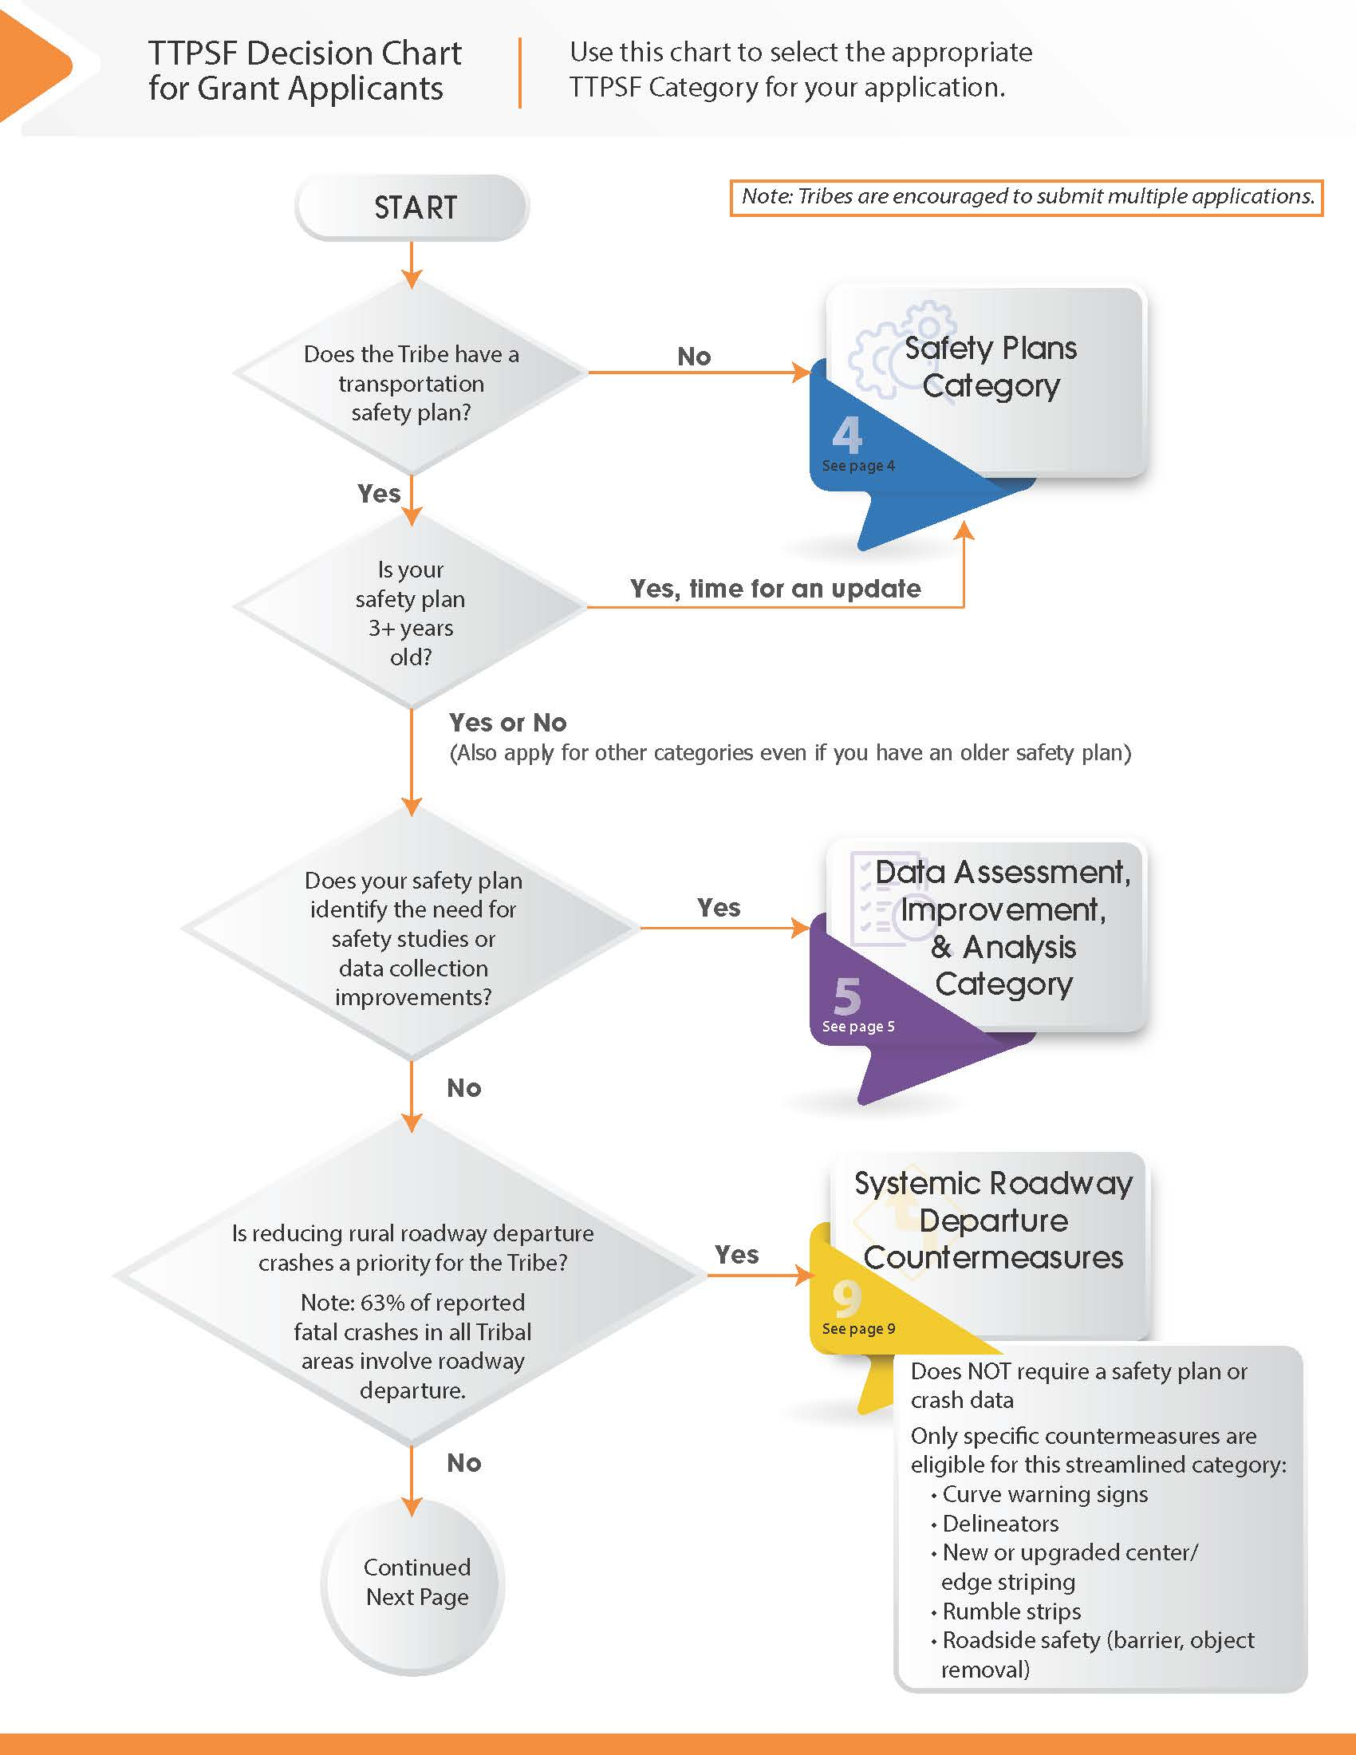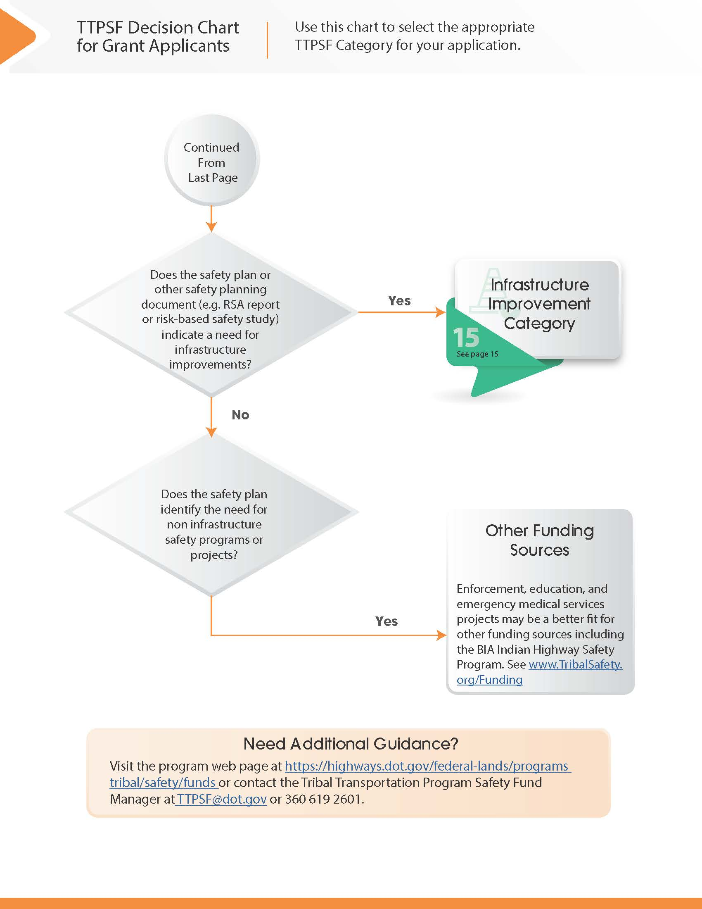

**Introduction:**

The TTPSF emphasizes the importance of strategic transportation safety plans. Tribes can use TTPSF funds to develop data-driven transportation safety plans. These plans help Tribes identify and document transportation safety needs in Tribal communities. The plans identify opportunities to reduce transportation-related fatalities and serious injuries and may include:

* A goal and timeline for eliminating fatalities and serious injuries;
* Collaboration with various safety stakeholder entities;
* Analysis of the location, severity, and contributing factors in vehicle-involved crashes;
* Analysis of community input, gathered through public outreach and education;
* Identification of risk factors that lead to serious injury or death;
* A data-driven approach to identify projects or strategies to prevent fatalities and serious injuries, which may include:
  + Education and community outreach;
  + Effective methods to enforce traffic laws and regulations;
  + New vehicle or other transportation-related technologies;
  + Roadway planning and design; and
  + Mechanisms for evaluating the outcomes and effectiveness of the transportation safety plan, including how that effectiveness will be reported to local residents.

More information on how to develop transportation safety plans can be found on the FHWA’s website at <https://highways.dot.gov/federal-lands/programs-tribal/safety/safety-plan-toolkit> or <https://www.tribalsafety.org/safety-planning-resources>.

To ensure eligibility for other Department of Transportation (DOT) grant programs, Tribes are also encouraged to consider the safety action plan requirements for the Safe Streets and Roads for All (SS4A) Program when developing and updating transportation safety plans. Safety action plans are transportation safety plans that include the specific [components](https://www.transportation.gov/grants/ss4a/action-plan-components) specified by SS4A. Resources are available on the SS4A web page at <https://www.transportation.gov/grants/SS4A/resources>.

**Instructions:**

1. The only activities eligible for the safety plans category are to a) create a Tribe’s first transportation safety plan or b) update an existing safety plan. 
   1. For applications to develop a Tribe’s *first* transportation safety plan (award maximum $15,000), submit only the [application form](https://highways.dot.gov/federal-lands/programs-tribal/safety/funds).
   2. For applications to *update* an existing safety plan (award maximum $10,000), submit the application form and a copy of the Tribe’s existing safety plan.
   3. **A project narrative is not required for this category for either activity type.**
2. Submit the completed application and any attachments by following instructions on the TTPSF web page at <https://highways.dot.gov/federal-lands/programs-tribal/safety/funds>

*Note:* In the same application period, you may apply for funding to update a safety plan and also for funding to implement projects supported by a previous safety plan or other safety planning document (e.g. Road Safety Audit, Risk-based Safety Study, or state safety plan). If applying for both funding to update a safety plan and funding for an additional TTPSF category, submit separate applications for each appropriate category.

**Introduction:**

Safety data is critical for making informed transportation safety decisions. Eligible activities for this category include:

* Planning for improvement of safety data using tools like the self-assessment tool in the Tribal Crash Reporting Toolkit at <https://www.tribalsafety.org/tribal-crash-reporting-toolkit> or more detailed traffic records assessments;
* Crash data improvement including software and technology to support electronic crash reporting;
* Technology to enable the electronic sharing of crash data with other jurisdictions;
* Collection of roadway asset data (when the applicant demonstrates how such data will be used to further transportation safety efforts);
* Risk-based (systemic) safety study to address a safety need across the roadway network;
* Road Safety Audit for a specific location; or
* Other study to better understand or document safety needs.

Do NOT use this category for engineering designs. Those projects will be considered under the infrastructure improvements category.

Data Assessment, Improvement, and Analysis projects may be conducted at the same time as the development or update of a Transportation Safety Plan (see previous category)

**Instructions:**

For projects eligible under the Data Assessment, Improvement, and Analysis category, follow these steps to apply for funding:

1. Develop a project narrative (See the recommended project narrative outline below).
2. Gather supporting documentation.
   1. Documentation that supports the statements made in the project narrative should be limited to relevant information. The project narrative must summarize any information that can be found in the supporting documentation. It is recommended that applicants provide an index of all submitted supporting documentation and use easy to understand file names.
3. Complete an [application form](https://highways.dot.gov/federal-lands/programs-tribal/safety/funds).
4. Submit the completed application form, project narrative, and any supporting documentation by following instructions on the TTPSF web page at <https://highways.dot.gov/federal-lands/programs-tribal/safety/funds>

**Recommended Project Narrative Outline:**

Applicants for the Data Assessment, Improvement, and Analysis Category are encouraged to use the project narrative template below. The template includes instructions explaining the information that should be included in each section.

**Table of Contents**

1. **Applicant Information:**
2. Tribe Name & Contact Information
3. Descriptive Title of Project
4. Funding Category: Data Assessment, Improvement, and Analysis
5. **Project Abstract:**

Describe project work that is to be completed under this request, the project purpose and safety benefit to the Tribe, and whether this is a complete project or part of a larger project with prior investment. It is important that your project abstract succinctly describes how this specific request for TTPSF funds will be used to complete your project. (Maximum: 5 Sentences)

1. **Project Description:**
2. Project location – Provide a brief description of the project location.
3. Provide a brief description of the proposed work:

Describe the scope of work that is to be completed with this funding request. This description should include answers to questions such as:

* + What are the safety needs and how does this project address them?
  + What are the strategic goals or priorities of the strategic safety planning document that are addressed by this project?
  + What is the intended outcome?
  + If this project will establish new sources of safety data, what additional safety analysis capabilities will be enabled?

Supporting documentation may be referenced in the project narrative and attached to the application.

1. Amount of TTPSF Funds Requested, Funding Packages, and Cost Estimate:

Provide a cost estimate that is reflective of the total cost of the proposed work by line item. Each line item in the cost breakdown must be associated with a task, deliverable, or outcome that contributes to the completed funding request.

If the applicant is willing to accept partial funding of the request, that should be explicitly stated. If partial funding is acceptable, the applicant should identify the individual components of the project that could be accomplished with partial funding and present funding packages that would accomplish these components. If only partial funding is available, this information will aid in the development of funding recommendations and provide the applicant the opportunity to fully complete individual components of the funding request.

TTPSF awards can be proposed as a non-federal match to other funding including the Highway Safety Improvement Program, Transportation Alternatives Program, and the Safe Streets and Roads for All (SS4A) Program. When other funding sources are proposed but not secured, the TTPSF application should present scenarios describing the independent components of the project that will be accomplished by the TTPSF award if other funding is not obtained. TTPSF awards will only be issued for complete projects or independent components of larger projects.

1. Project Schedule:

Provide an anticipated project schedule. Show when the work will be advanced, if funded. The schedule should also state the anticipated project completion date. Project schedules may show the anticipated calendar date when each task will be completed or the number of months relative to an award announcement. Grant awards are typically announced about four to five months after the application deadline.

Applications should only be submitted for projects or phases of projects that are ready to advance when funding is available.

1. **Coordination with Other Entities:**
2. Previous Federal funds contributed to this project:

Indicate the type of Federal funds, that this project has previously received, the Federal fiscal year, and the status of any work associated with these funds.

1. Commitment of Other Funds:

Indicate the amounts and sources of any private or other public funding being provided as part of this project.

1. Project Administration:

Indicate whether the project is being administered by the Tribal Government or another entity.

1. **Selection Criteria:**

As described in the NOFO Section E, projects will be selected based on the selection criteria, departmental selection criteria, commitment of other resources, and an evaluation of the applicant’s capacity to deliver the project. The project narrative should clearly identify how the project addresses these items. Include an anticipated rating for each selection criteria and a discussion of why that rating is appropriate. Appendix A describes how selection criteria will be evaluated.

1. Project Selection Criteria:

Projects are primarily selected for funding based on how well the application demonstrates alignment with the project selection criteria. Describe how the proposed project meets the Selection Criteria from the NOFO Section E.1 (Criteria) by addressing the questions below for Data Assessment, Improvement, and Analysis Projects (see other sections of this guide for other project types):

1. What strategic safety planning document(s) identify this project?

Please reference a page number or describe how this project is identified in the supporting strategic safety planning document(s).

For this category, the supporting strategic safety planning document must be a Tribe’s transportation safety plan or a state’s strategic highway safety plan.

1. Summarize the data that demonstrates the need for the project.
   * + *For traffic records assessments and improvements, including crash data collection:* An estimate of the data to be collected (such as approximate number of crashes per year) and a description of any process currently used to collect that data. Also describe how the data will be used.
     + *For Road Safety Audits (RSA):* Site specific data should be submitted which demonstrates an incident history or propensity on the specific roadway section(s) to be analyzed.
     + *For Systemic (Risk-based) Safety Studies and Roadway Asset Data Collection:* Data should be provided which demonstrates an incident history associated with the risk to be studied.

For example: High severity crashes at several intersections may prompt the study of risk factors at those intersections and a scan of the road network to see where similar conditions exist. This study may form the basis of a project to make improvements at high-risk sites based on the crash experience at a few sites.

1. What entity owns the facility(s)?

When applicable to the project (such as a Road Safety Audit or other location-based study), the road owner must provide a letter acknowledging the project unless the road is owned by the BIA or a Tribe. For projects not focused on a location(s), indicate that the project addresses Tribal area wide safety needs.

1. Status of Prior TTPSF Awards

Describe the status of projects funded by TTPSF awards in prior years. For completed projects provide an evaluation of the project’s success.

1. **Supporting Documentation:**

Include with the Project Narrative an index listing all supporting documentation. If including supporting documentation (such as maps, pictures, inventory data sheets, supporting data, etc.), label attachments with the Tribe and Project Title. Supporting documentation should further illustrate the information provided in the project narrative. Supporting documents are not likely to be reviewed if they are not summarized and referenced in the project narrative.

**Introduction:**

Tribes can reduce the risk of serious roadway departure crashes by making improvements to keep drivers in their lane, providing recovery areas, and establishing crashworthy roadsides. Roadway departure is a factor in **63%** of fatal motor vehicle crashes in Tribal areas, according to the Tribal Transportation Strategic Safety Plan (<https://www.tribalsafety.org/reports>). Most of these crashes involve only one vehicle and sometimes result from driver behavior factors, such as distraction, impairment, and error.

Roadway departure crashes in Tribal areas often result from similar risk factors, for example horizontal curves, narrow lane widths, misleading visual cues, hazardous roadsides, or low light conditions. However, roadway departure crashes in Tribal areas occur infrequently at a given location. For this reason, the systemic approach treats sites of higher risk instead of attempting to treat all sites or focusing only on crash history.

This category provides a streamlined application process to request funding to address rural roadway departure using only these specific low-cost safety countermeasures:

* Horizontal Alignment Warning Signs
* Delineators
* Center Line and Edge Line Markings (striping)
* Rumble Strips or Rumble Stripes
* Roadside Safety Improvements (removal of fixed objects, updating crashworthy roadside hardware, and installing guardrail or other barriers)

If the project involves any other countermeasures (such as shoulder widening or paving, high friction surface treatments, realignment, etc.) those must be submitted under the Infrastructure Improvements category.

Rather than relying on location-specific crash history, projects in this category will be selected by considering risk factors, roadway alignment, and ownership at the locations identified for improvement.

**Instructions:**

For projects eligible under the Systematic Roadway Departure Countermeasures category, follow these steps to apply for funding:

1. Make sure the improvements you are proposing are eligible for this category (see next page). Any other improvements will need to be submitted under the Infrastructure Improvements Category.
2. Identify the location, risk data, and proposed countermeasures for each location you plan to improve by completing the roadway departure countermeasure request form (provided below).
3. Compile a brief project narrative. (See recommended outline below.)
4. Complete the [application form](https://highways.dot.gov/federal-lands/programs-tribal/safety/funds).
5. Submit the completed application, countermeasure request form, and any attachments by following instructions on the TTPSF web page at <https://highways.dot.gov/federal-lands/programs-tribal/safety/funds>

Only the items illustrated below are eligible for the Systemic Roadway Departure Countermeasures Category. If applicants propose a project in this category for an improvement that is only eligible under other categories, the request may be removed from consideration, partially funded, or evaluated under the criteria of the Infrastructure Improvements Category.



**Recommended Project Narrative Outline:**

Applicants for the Systemic Roadway Departure Countermeasures Category are encouraged to use the project narrative template below. The template includes recommended language for each section. Additionally, applicants should complete any information requested in << brackets >>.

**Table of Contents**

1. **Project Abstract:**

*Recommended Language –* This project addresses roadway departure on the Tribe’s highest-risk roadways by implementing low-cost safety countermeasures. The proposed improvements are detailed on the attached Systematic Roadway Departure Countermeasure Request Form.

<<Add additional project description if needed to clarify the project>>

1. **Applicant information and coordination with other entities:**

<<Identify the name of the Tribal government, contact information, and any other entities involved in the project. If the project improves routes not owned by the Tribe, provide documentation that the road owner has acknowledged the funding request. >>

1. **Project Description:**

*Recommended Language –* This project uses a risk-based approach to address roadway departure by implementing countermeasures eligible for the Systemic Roadway Departure Countermeasures Category. The proposed improvements are proven safety countermeasures identified in the FHWA’s Focus on Reducing Rural Roadway Departures (FoRRRwD) initiative (<https://highways.dot.gov/safety/rwd/forrrwd/forrrwd-resources>).

The specific locations and improvements are detailed on the enclosed forms. The following list presents a summary of these locations from highest risk to lowest risk:

<<Insert a prioritized list of the roadways proposed for improvement >>

The Tribe anticipates that NEPA requirements will be satisfied by a categorical exclusion for all improvements proposed in this application.

<<Insert any proposed improvements that may require higher level NEPA review>>

If this application is selected, the Tribe will maintain signs and striping by…

<<Insert a description of the sign and pavement marking maintenance method used by the Tribe. See the Manual of Uniform Traffic Control Devices (MUTCD) Sections 2A.08 and 3A.03.>>

1. **Grant Funds and Sources/Uses of Project Funds, Scope, Schedule:**

<<Summarize the total budget for this project. Include any additional anticipated costs, such as design costs, as a percentage of the improvements. The following table is one method you can use for the budget>>

|  |  |
| --- | --- |
| **Budget Item** | **Cost** |
| Location 1: | $ |
| Location 2: | $ |
| Location 3: | $ |
| Design Cost (x%) | $ |
| **Total Project Cost** | **$** |

<<Identify any matching funds (including TTP shares and in-kind match) that will be contributed to this project. Matching resources are not required and have minimal influence on the selection process.>>

<<Present a schedule demonstrating when the project will be completed. The schedule can be based on time after award date rather than calendar date.>>

1. **Selection Criteria:**

Describe how the proposal meets the Selection Criteria by reviewing the proposed selection criteria responses below. It may not be necessary to edit the provided text. See Appendix A of this guide or NOFO Section E.1 (Criteria) for details on how these criteria are evaluated.

* Criterion 1: Strategic Safety Planning:

Roadway Departure is a factor in 63% of fatal motor vehicle crashes in Tribal areas. Addressing roadway departure is an emphasis topic in the Tribal Transportation Strategic Safety Plan (<https://www.tribalsafety.org/reports>).

<<Optional: If applicable, reference any section of the Tribe’s transportation safety plan that addresses roadway departure.>>

* Criterion 2: Supporting Safety Data

Risk data is provided on the attached forms to demonstrate the need at the location proposed for improvement. The applicant understands that the project may be partially funded if there is high competition in this category and locations documented as higher risk will be selected first.

* Criterion 3: Systemic Prioritization

The attached forms document the alignment of the locations proposed for improvement. The applicant understands that the project may be partially funded if there is high competition in this category and proposals that focus on safety improvements to horizontal curves may be selected before straight tangent sections of road.

* Criterion 4: Facility ownership

The attached forms document the facility ownership for each proposed location. The applicant has included a letter acknowledging the proposed improvements from any road owners that are not BIA or the Tribe.

[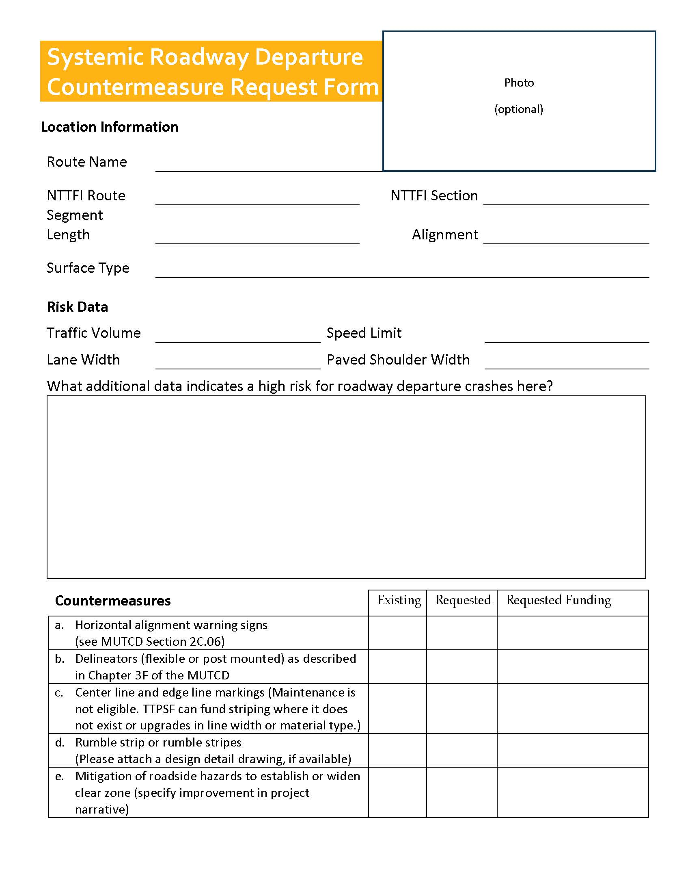](https://highways.dot.gov/federal-lands/programs-tribal/safety/funds)

**Instructions for the Systemic Roadway Departure Countermeasure Request Form**

Complete a separate form for each route and section proposed for improvement. Applications containing greater detail may be more competitive. A fillable PDF version of this form is [available online](https://highways.dot.gov/federal-lands/programs-tribal/safety/funds). A description of each field is below:

**Location Information**

* *Road Name* – Common description for the segment of road.
* *National Tribal Transportation Facility Inventory (NTTFI) Route and Section Number* – Routes must be official in the inventory.
* *Segment Length* – approximate length in miles
* *Alignment* – Curves, Tangents (straight sections), Both
* *Surface Type* – Dirt, Gravel, Paved

**Risk Information –**

* *Traffic Volume* – Qualitative responses (high or low volume) or estimates may be used in lieu of average annual daily vehicle counts.
* *Posted Speed Limit*
* *Lane Width* – Width of paved lane or half the width of unpaved surface
* *Paved Shoulder Width* – Paved shoulder width; Enter 0ft for unpaved.
* *Additional Risk Data* - What additional data indicates a high risk for roadway departure crashes here? - Describe any roadway attributes that would suggest this location needs to be improved. An elevated risk of roadway departure crashes may be indicated by:
  + Roadway geometry (i.e. sharp curve)
  + Intersection within a curve
  + Misleading visual cues
  + Speed study results including curve advisory speed
  + Pavement edge conditions
  + Terrain (i.e. steep drop-offs, cliff, embankment)
  + Shoulder design
  + Hazardous objects in the clear zone
  + Site-specific crash experience
  + Other site-specific conditions

**Site Photos (optional) –** Although optional, including a photo could help reviewers better understand the risks being described.

**Countermeasures –** Indicate both existing safety countermeasures and the new countermeasures for which you are requesting funding. Document the requested funding amount for each proposed improvement. Only items listed below are eligible for this category:

a. Horizontal Alignment Warning Signs - (see [MUTCD Section 2C.06](https://mutcd.fhwa.dot.gov/htm/2009/part2/part2c.htm#section2C06))

b. Delineators (flexible or post mounted) - as described in [Chapter 3F](https://mutcd.fhwa.dot.gov/htm/2009/part3/part3f.htm) of the MUTCD

c. Center Line and Edge Line Markings (striping) - Maintenance is not eligible. TTPSF can fund new striping where it does not exist or upgrades in line width or material type.

d. Rumble Strip or Rumble Stripes - Please attach a design detail drawing, if available

e. Roadside Safety Improvements - mitigation of roadside hazards to establish or widen clear zone. This may include clearing and grubbing, object markers, removing hazardous objects, new or upgraded guardrail, upgrading to crashworthy drainage structures and other roadside hardware. Shoulder widening and slope flattening are not eligible for this category but may be submitted to the infrastructure improvements category.

**Introduction:**

Most TTPSF applications are submitted under the Infrastructure Improvement Category.

A wide variety of projects are eligible for this category. This category is flexible to the needs identified in a Tribe’s transportation safety plan. Typical projects submitted under this category include pedestrian, intersection, speed management, and roadway departure safety improvements. Applicants should review the [FHWA Proven Safety Countermeasures](https://highways.dot.gov/safety/proven-safety-countermeasures) and the non-exhaustive eligibility list in [23 U.S.C. § 148(a)(4)](https://uscode.house.gov/view.xhtml?req=(title:23%20section:148%20edition:prelim)%20OR%20(granuleid:USC-prelim-title23-section148)&f=treesort&edition=prelim&num=0&jumpTo=true) for examples of projects that are eligible for the Infrastructure Improvements category.

**Instructions:**

For projects eligible under the Infrastructure Improvement category, follow these steps to apply for funding:

1. Develop a project narrative (see recommended outline below).
2. Gather supporting documentation.
   1. Documentation that supports the statements made in the project narrative should be limited to relevant information. The project narrative must summarize any information that can be found in the supporting documentation. It is recommended that applicants provide an index of all submitted supporting documentation and use easy to understand file names.
3. Complete an [application form](https://highways.dot.gov/federal-lands/programs-tribal/safety/funds).
4. Submit the completed application form, project narrative, and any supporting documentation by following instructions on the TTPSF web page at <https://highways.dot.gov/federal-lands/programs-tribal/safety/funds>.

**Recommended Project Narrative Outline:**

Applicants for the Infrastructure Improvement Category are encouraged to use the project narrative template below. The template includes instructions explaining the information that should be included in each section.

**Table of Contents**

1. **Applicant Information:**
2. Tribe Name & Contact Information: This should match the application form.
3. Descriptive Title of Project: This should match on the description provided in the application form and be a very short project description that readily identifies the project or is commonly used to describe the project.
4. Funding Category: Infrastructure Improvement
5. **Project Abstract:**

Describe project work that is to be completed under this request, the project purpose and safety benefit to the Tribe, and whether this is a complete project or part of a larger project with prior investment. It is important that your project abstract succinctly describes how this specific request for TTPSF funds will be used to complete your project. (Maximum: 5 Sentences)

1. **Project Description**
2. Location: Provide a brief description of the project location.

* Length of project & project limits: Identify the length of the project in miles. Include a narrative description of the project termini and the National Tribal Transportation Facility Inventory (NTTFI) route and section number(s).

1. Provide a brief description of the proposed work:

Describe the scope of work that is to be completed with this funding request. This description should include answers to questions such as:

* What are the safety needs and how does this project address them?
* What are the strategic goals or priorities of the strategic safety planning document that are addressed by this project?
* Is this a complete project or part of a larger phased project?
* What is the intended outcome?
* What is the status of compliance with the National Environmental Policy Act?

Only include work that is eligible for TTPSF funding. See the NOFO for TTPSF

selection and eligibility criterion.

Appropriate supporting documentation should be referenced in this narrative and

copies of the documentation provided with the application.

1. Amount of TTPSF Funds Requested, Funding Packages, and Cost Estimate:

Provide a cost estimate that is reflective of the total cost of the proposed work by line item. Each line item in the cost breakdown must be associated with a task, deliverable, or outcome that contributes to the completed funding request. A cost estimate for a Safety Plan can be a lump sum.

If the applicant is willing to accept partial funding of the request, that should be explicitly stated. If partial funding is acceptable, the applicant should identify the individual components of the project that could be accomplished with partial funding and present funding packages that would accomplish these components. If only partial funding is available, this information will aid in the development of funding recommendations and provide the applicant the opportunity to fully complete individual components of the funding request.

TTPSF awards can be proposed as a non-federal match to other funding including the Highway Safety Improvement Program, Transportation Alternatives Program, and the Safe Streets and Roads for All (SS4A) Program. When other funding sources are proposed but not secured, the TTPSF application should present scenarios describing the independent components of the project that will be accomplished by the TTPSF award if other funding is not obtained. TTPSF awards will only be issued for complete projects or independent components of larger projects.

1. Project Schedule:

The anticipated project schedule is required. The schedule should show how the work will be advanced if funded. The schedule should also state the anticipated project completion date. This should directly reference each line item in the cost estimate. Applications should only be submitted for projects or phases of projects that are ready to advance when funding is available. The project schedule should identify if the funds will be obligated within one year of the date the funds are made available.

1. **Coordination with Other Entities**
2. Previous Federal funds contributed to this project:

Indicate the type of Federal funds, that this project has previously received, the Federal fiscal year, and the current status of any work associated with these funds.

1. Commitment of Other Funds:

Indicate the amounts and sources of any private or other public funding being provided as part of this project. Only indicate those amounts of funding that are firm and documented commitments from the entity controlling the funds.

1. Project Administration:

Indicate if the project will be administered by the Tribal Government or another entity.

1. **Selection Criteria**

The NOFO describes the application review and selection process. Projects will be selected based on the selection criteria, departmental selection criteria, commitment of other resources, and an evaluation of the applicant’s capacity to deliver the project. The project narrative should clearly identify how the project addresses these items. Applications should state your anticipated rating for each selection criteria along with a discussion of why that rating is appropriate.

1. Project Selection Criteria

Projects are primarily selected for funding based on how well the application demonstrates alignment with the project selection criteria. Describe how the proposal meets the Selection Criteria by responding to the following questions. See Appendix A of this guide or NOFO Section E.1 (Criteria) for details on how these criteria are evaluated.

1. What strategic safety planning document(s) identify this project?

* Please provide a page number or describe where this project is identified in the supporting strategic safety planning document(s).
* The strategic safety planning document may be a state Strategic Highway Safety Plan, a Tribe’s transportation safety plan, Road Safety Audit, systemic (risk-based) safety study, or other safety engineering study.

1. Summarize any data that clearly demonstrates the need for the project.

* Summarize the best available data that demonstrates a history or risk of transportation incidents that are expected to be reduced by the proposed activity. Describe the type, severity, and quantity of incidents that directly demonstrate the need for the project.
* Average daily traffic volumes, pedestrian volumes, traffic citation statistics, public surveys, roadway alignment data, and sign inventories are examples of alternative safety data sources which could be used to demonstrate risk at the project location and supplement relevant incident history.
* In some cases, crashes may not have occurred at a location but the risks suggest future crashes may occur. In such cases, alternative safety data sources can demonstrate risks at the location proposed for improvement are similar to risk elements at other locations where crashes have occurred. A risk-based (systemic) safety study can be a useful planning tool to document such circumstances.

1. Identify evidence that the project is likely to reduce crash frequency and/or severity.

* When available, reference supporting publications, such as the FHWA’s proven safety countermeasures or the Crash Modification Factors Clearinghouse. Similar references or studies may also be acceptable.

1. Route Information

* Demonstrate the National Tribal Transportation Facility Inventory (NTTFI) status of routes proposed for improvement. Also document the route owner. For routes not owned by the BIA or a Tribe, applicants must include a letter from the road owner acknowledging the project.

1. What is the age and status of prior TTPSF awards?

* Describe the status of projects funded by TTPSF awards in prior years. Also document the year of award. For completed projects, provide an evaluation of the project’s success in improving transportation safety.

1. Departmental Selection Criteria

After considering other project selection criteria, the departmental selection criteria may be considered by FHWA. Describe how the proposal meets any applicable Departmental Selection Criteria from the NOFO Section E.2.

1. **Supporting Documentation.**

Include with the Project Narrative an index listing all supporting documents (such as maps, pictures, inventory data sheets, supporting data, etc.). Label attachments with the Tribe name and Project Title.

1. Letter from Facility owner

All applications involving infrastructure improvement must be accompanied by a letter from the facility owner(s) acknowledging awareness of the project. Facilities owned by a Tribe or BIA are exempt from this requirement.

1. Inventory Data Sheets

Applicants should include documentation that the routes proposed for improvement are official and existing (not proposed roads) on the National Tribal Transportation Facility Inventory (NTTFI), an eligibility requirement. One possible source of such documentation is the Regional NTTFI Reports posted online at https://itims.bia.gov/.

1. Other Attachments

Supporting documentation should further illustrate the information provided in the project narrative. Supporting documents are not likely to be reviewed if they are not summarized and referenced in the project narrative.

**Appendix A. Selection Criteria Guide**

Below is a guide describing how the selection criteria will be evaluated. Applicants should carefully review the official selection criteria in Section E of the Notice of Funding Opportunity (NOFO). The project narrative should thoroughly address the selection criteria. A project must meet highly qualified (**HQ**) standards for all criteria to be ranked as highly qualified. A project must meet either qualified (**Q**) or **HQ** standards for all criteria to be ranked as qualified. If a project meets the standards for not qualified (**NQ**) for any of the selection criteria, the project will be ranked not qualified.

|  |  |
| --- | --- |
| **Category: SAFETY PLANS** | |
| **Selection Criteria Description** | **Rating Guide** |
| **What is the age and status of existing transportation safety plans?**  (Or is this application for funding to develop the Tribe’s first transportation safety plan?) | **HQ**: Requests (up to $15,000) to develop a new transportation safety plan or requests (up to $10,000) to update existing Tribal transportation safety plans that are at least 3 years old.  **Q**: N/A  **NQ**: Projects that do not meet the eligibility requirements; request to update a transportation safety plan that is less than 3 years old. |
| **Describe how funding will be used in the development or update of a Tribal Transportation Safety Plan.** |

|  |  |
| --- | --- |
| **Category: DATA ASSESSMENT, IMPROVEMENT, AND ANALYSIS ACTIVITIES** | |
| For this category, all criteria will be evaluated but greater consideration will be given to criteria 1 and 2. | |
| **Selection Criteria Description** | **Rating Guide** |
| **Criterion 1. What strategic safety planning document(s) identify this project?**  Please provide a page number or describe where this project is identified in the supporting strategic document(s).  For this category, the supporting strategic safety planning document must be a transportation safety plan developed by a Tribe or a state’s strategic highway safety plan. | **HQ**: Requests that are in a current State SHSP or a Tribe’s transportation safety plan that is five years old or newer.  **Q**: Requests that are in the most recent State SHSP or a Tribe’s transportation safety plan (the supporting plan is more than five years old).  **NQ**: The application did not provide documentation that would demonstrate that the project is supported by a safety plan. |
| **Criterion 2. Summarize data that demonstrates the need for the project.**   * *For traffic records assessments and improvements:*   An estimate of the data to be collected (such as approximate number of crashes per year) and a description of any process currently used to collect that data. Also describe how the data will be used.   * *For Road Safety Audits (RSA):*   Site specific data should be submitted that demonstrates an incident history or propensity on the specific roadway to be analyzed.   * *For Systemic Safety Studies:*   Data should be provided that demonstrates an incident history associated with the risk factor to be studied. | **HQ**: Submission of data, as specified for the specific project type, that clearly demonstrate the need for the activities.  **Q**: Submission of some data, as specified for the specific project type, that demonstrate the need for the activity.  **NQ**: No applicable supporting data was provided to demonstrate the need for the activity. |
| **Criterion 3. What entity owns the facility(s)?**  When applicable to the project (such as a Road Safety Audit or other study), the road owner must provide a letter acknowledging the project unless the road is owned by the BIA or a Tribe. | **HQ**: Project addresses safety needs on a facility owned by a Tribe or BIA, including where a route owned by a Tribe or BIA intersects with a facility not owned by BIA or a Tribe and the road owner has provided a letter acknowledging the project.  **Q**: Project addresses safety needs on a facility not owned by a Tribe or BIA and the road owner has provided a letter acknowledging the project.  **NQ**: Project is located on a route that is not owned by BIA or a Tribe and the road owner did not provide documentation acknowledging the project. |

|  |  |
| --- | --- |
| **Category:**  **SYSTEMIC ROADWAY DEPARTURE COUNTERMEASURES** | |
| An application in this category may propose to improve multiple locations. Each location will be evaluated individually, which may result in partial funding of an application. For this category all criteria will be evaluated with equal importance. | |
| **Criteria Description** | **Rating Guide** |
| **Criterion 1. What strategic safety planning document(s) identify this project?**  Please provide a page number or describe where this project is identified in the supporting strategic safety planning document(s). | **HQ**: The need to address roadway departure is identified in a Tribe’s current transportation safety plan that is five years old or newer.  **Q**: The need to address roadway departure is identified in the 2017 Tribal Transportation Strategic Safety Plan ([www.TribalSafety.org/reports](http://www.TribalSafety.org/reports)), a current State SHSP, or a Tribe’s transportation safety plan that is more than five years old.  **NQ**: N/A |
| **Criterion 2. Supporting Safety Data**  For this category both crash experience and other risk factors will be evaluated for each horizontal curve or tangent segment submitted.  Document crash experience or other risk considerations for each horizontal curve or tangent location. This may be done using [the risk assessment form](https://highways.dot.gov/sites/fhwa.dot.gov/files/images/Systemic%20RwD%20Risk%20Assessment%20Form%20-%20FINAL.pdf) for the systemic roadway departure countermeasures category | **HQ:** Submission of data that directly demonstrate high risk at the location to be improved by the project.  **Q:** Submission of some data that demonstrate risk at the location to be improved by the project.  **NQ**: Insufficient supporting data were provided to demonstrate the need for the activity. |
| **Criterion 3. Systemic Prioritization** | Improvements to horizontal curves will generally be prioritized over improvements in tangent sections as described in Section A of the Notice of Funding Opportunity. Risk data and other factors for each location could result in some tangent sections being selected before some horizontal curves. Curves will be rated highly qualified for this criterion while tangents will be rated as qualified. |
| **Route number(s) from the National Tribal Transportation Facility Inventory (NTTFI)** | Required for systemic roadway departure countermeasures and infrastructure improvement projects. Routes must be both official and existing (not proposed roads) to be eligible. |
| **Criterion 4. What entity owns the facility(s)?** | **HQ**: Improvements to a facility owned by a Tribe or BIA that is an official and existing route in the NTTFI.  **Q**: Facility not owned by a Tribe or BIA but road owner provides a letter acknowledging the proposed project.  **NQ**: Improvements are located on a route that is not official or existing on the NTTFI or project is located on a route not owned by BIA or a Tribe and the road owner did not provide documentation acknowledging the proposed improvements. |

|  |  |
| --- | --- |
| **Category:**  **INFRASTRUCTURE IMPROVEMENT**  **AND OTHER ELIGIBLE ACTIVITIES AS LISTED IN 23 U.S.C. 148(A)(4)** | |
| For this category, all criteria will be evaluated but greater consideration will be given to criteria 1, 2, and 3. | |
| **Criteria Description** | **Rating Guide** |
| **Criterion 1. What strategic safety planning document(s) identify this project?**  Please provide a page number or describe where this project is identified in the supporting strategic safety planning document(s).  The strategic safety planning document may be a state Strategic Highway Safety Plan, a Tribe’s transportation safety plan, Road Safety Audit, or other safety engineering study. | **HQ**: Project is identified in a current State SHSP, Tribe’s transportation safety plan, RSA, or other safety engineering study. The supporting document is five years old or newer;  **Q**: Project is identified in a current SHSP, a Tribe’s transportation safety plan, RSA, or other safety engineering study. The supporting document is more than five years old;  **NQ**: The application did not provide documentation that demonstrates that the project is supported by a State SHSP, Tribe’s transportation safety plan, RSA, or other safety engineering study. |
| **Criterion 2. Summarize any data that clearly demonstrates the need for the project.**  Summarize the best available data that demonstrates a history or risk of transportation incidents which are expected to be reduced by the proposed activity.  Average daily traffic volumes, pedestrian volumes, traffic citation statistics, public surveys, and sign inventories are examples of alternative safety data sources which could be used to demonstrate risk at the project location and supplement relevant incident history. | **HQ**: Submission of data describing the type, severity, and quantity of incidents that directly demonstrate the need for the project. This should be site specific data that describes the crash history and directly demonstrates the safety need.  **Q**: Submission of some data that demonstrate the need for the project. This data could be an area-wide incident history (such as the results of a systemic safety study or regional safety plan) and some supporting data from an alternative safety data source.  **NQ**: No supporting data was provided to demonstrate the need for the activity. |
| **Criterion 3. Identify evidence that the project is likely to reduce crash frequency and/or severity.**  When available, reference supporting publications such as the [FHWA’s proven safety countermeasures](https://safety.fhwa.dot.gov/provencountermeasures/)  or the [Crash Modification Factors Clearinghouse](http://www.cmfclearinghouse.org/) | **HQ:** The application references evidence that demonstrates the proposed project is likely to reduce crash frequency/severity.  **Q:** Although the project is likely to reduce crash frequency and/or severity, the application does not reference evidence quantifying the expected crash reduction.  **NQ**: N/A for this criterion. |
| **Criterion 4. What entity owns the facility(s)?** | **HQ**: Project located on a BIA or Tribal facility; The intersection of a Tribal/BIA route with a facility of another ownership will be considered HQ for this criterion.  **Q**: Facility not owned by a Tribe or BIA but road owner provides a letter acknowledging the proposed project.  **NQ**: Not a Tribal or BIA route and no letter from the road owner. |
| **Route number(s) from the National Tribal Transportation Facility Inventory (NTTFI)** | Required for infrastructure improvement projects. Routes must be both official and existing (not proposed roads) to be eligible. |
| **Criterion 5. Prior TTPSF Awards** | **HQ**: The Tribe has not received funding for a TTPSF transportation safety construction project in more than 5 years.  **Q**: Tribe has received funding for a TTPSF transportation safety construction project within the past 5 years.  **NQ**: N/A for this criterion. |